

**C.K.Pithawalla College of Commerce-Management-Computer Application, Surat**

VEER NARMAD SOUTH GUJARAT UNIVERSITY, SURAT

PROJECT REPORT

ON

**Internet banking management**

AS A PARTIAL REQUIREMENT FOR THE DEGREE

OF

BACHELOR OF COMPUTER APPLICATION

(B.C.A)

2024-2025

**SUBMITTED BY:**

**Jenil Dhola(7298)**

**Harsh Lakhani (7313)**

**Darshan Lakhani (7312)**

**Utsav Chheta (7294)**

**GUIDED BY:**

**Dr.Ami Desai**

**Mr. Juned Ansari**

**Acknowledgement**

The reason of completing the project work successfully is not just our efforts but efforts of many people. The people, who trusted, guided and encouraged us with every means. Guide is a person who provides you the direction towards success, so we feel great pleasure to express our gratitude to all our guides, our faculty members as well as every person who helped me directly or indirectly with our project.

We would like to thank **Dr. Marteen Patel** (In-charge Principal at C.K.Pithawalla College)and **Mr. Gaurang Joshi** (BCA-HOD at C.K.Pithawalla College)for granting us an opportunity to work on this project. Their skills and experience was a guiding path in this learning process. She made constant efforts to shape up our skills as per the industry Standards. She provided us a very homely and friendly environment which made it the best place to work. Their guidance was really priceless and will always be a guiding light in Industry.

We are also indebted to our Faculty **Dr.Ami Desai** who provided constant encouragement, support & valuable guidance before and during our project. It was her effort who led us to this place for project work. Her guidance and suggestions were invaluable.

**Jenil Dhola(7298)**

**Harsh Lakhani (7313)**

**Darshan Lakhani(7312)**

**Utsav Chheta (7294)**

Thank you very much

|  |  |  |  |
| --- | --- | --- | --- |
| Index | | | |
| SrNo | **Chapter** | | **Page No** |
| 1 | **Introduction** | | **1** |
|  | 1.1 | Project Profile | 2 |
|  | 1.2 | Project Introduction | 3 |
| 2 | **Environment Description** | | **4** |
|  | 2.1 | Hardware Software Requirement | 5 |
|  | 2.2 | Tools & Technology | 6 |
| 3 | **Existing System & its Limitation** | | **4** |
|  | 3.1 | Introduction | 5 |
|  | 3.2 | Limitation | 6 |
| 4 | **Proposed System** | | **13** |
|  | 4.1 | Scope | 14 |
|  | 4.2 | Aims & Objectives | 18 |
|  | 4.3 | Excepted Advantage | 19 |
| 5 | **System Model Architecture** | | **29** |
|  | 5.1 | Use Case Diagram | 30 |
|  | 5.2 | Activity Diagram | 33 |
| 6 | **System Diagram** | | **67** |
|  | 6.1 | Table Structure | 75 |
|  | 6.2 | Screen Layout | 76 |
| 7 | **System Limitations & Future Enhancements** | | **206** |
|  | 7.1 | System Limitations |  |
|  | 7.2 | Future Enhancements |  |
| 8 | **References** | | **208** |
|  | 8.1 | Bibliography | 209 |
|  | 8.2 | Webography | 210 |

**1**

Chapter

**Introduction**

|  |  |
| --- | --- |
| 1.1 | Project Profile |
| 1.2 | Project Introduction |

**1.1 Project Profile**

|  |  |  |
| --- | --- | --- |
| **Project Title** | **:** | **Internet Banking Management** |
| **Objective** | **:** | To provide a secure and efficient platform for online banking services |
| **Name of the Institute** | **:** | C.K.Pithawalla College of Commerce-Management - Computer Application |
| **Developed For** | **:** | DigiBankX |
| **Project Guide** | **:** | Dr.Ami Desai |
| **Front End** | **:** | PHP |
| **Back End** | **:** | MySQL |
| **Team Members** | **:** | 4 |

**1.2 Project Introduction**

**Introduction to DigibankX - Internet Banking Management System**

* DigibankX is an advanced online banking system designed to simplify and manage various banking activities such as transactions, loans, and complaints.
* It features three key panels: Admin, Staff, and Client, ensuring organized control and efficient workflow.
* The Admin panel handles user management, financial reports, and complaint resolution.
* The Staff panel manages client profiles, transactions, and loan approvals.
* The Client panel allows users to manage accounts, apply for loans, and file complaints.
* The system is designed with strong data validation, ensuring accurate information entry and improved security.
* DigibankX currently supports only domestic transactions, requires manual loan approvals, and may face delays in complaint handling during busy periods.
* Future plans include introducing automated loan approvals, biometric authentication for improved security, and multilingual support for wider accessibility.
* Additional enhancements like a mobile app and improved financial reports with visual insights are planned to improve user convenience and system efficiency.
* The project is developed using HTML, CSS, JavaScript, and AJAX for the front-end, while PHP and MySQL power the back-end.
* Libraries like SweetAlert and jQuery are integrated for better alerts, form handling, and dynamic updates.
* DigibankX aims to provide a secure, reliable, and user-friendly platform for efficient online banking services.

**2**

Chapter

**Environment Description**

|  |  |  |  |
| --- | --- | --- | --- |
| **2.1** | **Hardware and Software Requirement** | | |
|  | | 2.1.1 | Development Tools | |
|  | | 2.1.2 | Client Side Tools | | |
| 2.1.3 | Server Side Tools | | |
| **2.2** | **Tools and Technology** | | |
|  | | 2.2.1 | Core Technology | | | |
| 2.2.2 | Extra Tools | | | |

**2.1 Hardware and Software Requirement**

* + **Client Side :**

**Internet enabled devices with Web Browser**

* + **Server Side :-**

**Xampp Server (8.0.3)**

**Disk Space (1 GB)**

* + **Development Side :**

**Processor (Intel CORE i5 11th gen)**

**O.S (Windows 11 Pro)**

**Memory (16 GB)**

**Hard Disk (500 GB)**

**Web Browser : Developed in Google Chrome(Tested in Google Chrome)**

**2.2 Tools and Technology**

**Technology:**

* **Core Technology** :
* **HTML:**

**-** First developed by Tim Berners-Lee in 1990, **HTML** is short for Hypertext Markup Language.

**- HTML** is used to create electronic documents (called pages) that are displayed on the World Wide Web.

**-** Each page contains a series of connections to other pages called hyperlinks.

* **MySQL:**

**- MySQL**, the most popular Open Source SQL database management system, is developed, distributed, and supported by Oracle Corporation.

**-** The **MySQL** website (http://www.**mysql**.com/) provides the latest **information about MySQL** software.

**-** A database is a structured collection of data.

* **PHP:**

**-** Hypertext Preprocessor (or simply **PHP**) is a general-purpose programming language was 32-bit x86 builds, requiring Windows 32-bit compatibility mode while using **Internet** **Information** **Services** (IIS) on a 64-bit Windows platform.

* **Extra Technology:**
* **JQuery:**

**- JQuery** is a JavaScript library designed to simplify HTML DOM tree traversal and manipulation, as well as event handling, CSS animation, and Ajax.

**- JQuery** also provides capabilities for developers to create plug-ins on top of the JavaScript library.

* **AJAX:**

**- AJAX** is a technique for creating fast and dynamic web pages.

**-** **AJAX** allows web pages to be updated asynchronously by exchanging small amounts of data with the server behind the scenes.

**-** This means that it is possible to update parts of a web page, without reloading the whole page.

* **JavaScript:**

**- JavaScript** is a dynamic computer programming language.

**-** It is lightweight and most commonly used as a part of web pages, whose implementations allow client-side script to interact with the user and make dynamic pages.

**-** It is an interpreted programming language with object-oriented capabilities.

**Tools:**

* **Documentation Tools:**
* **MS Word:**

**- Microsoft Word** or **MS**-**WORD** (often called **Word**) is a Graphical **word** processing program that users can type with.

**-** It is made by the computer company **Microsoft**. Its purpose is to allow users to type and save documents.

* **MS Power Point:**

**- PowerPoint** is a slideshow presentation program that's part of the **Microsoft** office suite of tools.

**- PowerPoint** makes it easy to create, collaborate, and present your ideas in dynamic, visually compelling ways.

* **Development Tools:**

**Visual Studio Code**

* **Visual Studio Code (VS Code)** is a powerful and versatile code editor used for developing the **DigiBankX** project.
* It offers a clean, functional, and fast environment ideal for writing PHP, HTML, CSS, and JavaScript code.
* VS Code provides excellent built-in features such as **IntelliSense**, **Git Integration**, and **Debugging Tools**, which streamline the development process.
* Additionally, its extensive support for **extensions**, **snippets**, and customizable settings enhances productivity and makes coding efficient.
* The lightweight yet feature-rich nature of VS Code played a crucial role in developing and maintaining the robust features of **DigiBankX**.

**3**

Chapter

|  |  |
| --- | --- |
| 3.1  3.2 | Introduction  Limitation |

**Existing System**

**3.1 Introduction**

In traditional banking systems, clients often need to visit a physical bank branch to perform various financial tasks such as transactions, loan applications, and complaint submissions. This process can be time-consuming, inconvenient, and inefficient.

### Challenges in the Existing System

• **Limited Service Availability:** Clients have restricted access to banking services outside regular banking hours, causing delays in essential financial activities.  
• **Lack of Real-Time Updates:** Tracking transactions, loan statuses, or complaint resolutions often requires direct interaction with bank staff, leading to frustration and uncertainty.  
• **Manual Processes:** Paper-based procedures and in-person verifications contribute to delays and errors.  
• **Inconvenient Documentation:** Clients often need to carry physical documents for every visit, adding to their burden.  
• **Geographical Constraints:** Clients in remote areas may struggle to access physical bank branches, limiting their ability to manage finances efficiently.  
• **Security Risks:** Handling cash transactions at physical branches may expose clients to potential theft or fraud.

### The DigiBankX Solution

DigiBankX overcomes these challenges by providing a **secure**, **efficient**, and **user-friendly** platform that enables clients to manage their banking needs online, anytime and anywhere. Key features include:

✅ **24/7 Digital Banking Services:** Clients can perform transactions, apply for loans, and submit complaints at their convenience.  
✅ **Real-Time Transaction Tracking:** Clients can monitor their account activities, loan statuses, and complaint progress with live updates.  
✅ **Paperless Documentation:** Digital forms simplify the submission process, eliminating the need for repeated physical documentation.  
✅ **Enhanced Security:** Strong encryption protocols, two-factor authentication, and secure login mechanisms ensure data protection.  
✅ **User-Centric Design:** The platform offers an intuitive interface, making online banking accessible even to users with limited technical knowledge.  
✅ **Remote Access:** Clients can manage their finances from anywhere, improving financial inclusion for underserved regions.

By adopting DigiBankX, both clients and bank staff can enjoy a smoother, faster, and more secure banking experience.

**3.2 Limitation**

• **Limited Service Hours:** Traditional banking systems operate within fixed working hours, restricting clients from performing transactions, applying for loans, or submitting complaints outside those hours.

• **Limited Access to Services:** Clients may face inconvenience if specific banking services are unavailable at their nearest branch, requiring them to visit multiple locations.

• **Delayed Processes:** Manual paperwork, long queues, and in-person visits often result in delays for essential banking tasks like loan approvals and account updates.

• **Lack of Real-Time Updates:** Clients may struggle to track their transaction status, loan progress, or complaint resolution without a digital platform, causing frustration and time loss.

**4**

Chapter

|  |  |
| --- | --- |
|  | 4.1 Scope  4.2 Aim and Objective  4.3 Excepted Advantage |

**Proposed System**

**4.1 Scope**

* The scope of the website “**Wooden Street”** is global.

SCOPE

ADMIN

STAFF

CLIENT

VISITOR

### ****Admin****

The key roles of the Admin in DigibankX are:

* **User Management:**
  + View, activate, or deactivate registered Staff and Clients.
  + Block or unblock Staff and Clients as needed.
* **Loan Management:**
  + View and manage loan applications submitted by Clients.
  + Approve or reject loan requests based on eligibility criteria.
* **Transaction Management:**
  + Monitor all client transactions for security and accuracy.
  + Manage disputed transactions and ensure proper resolution.
* **Complaint Management:**
  + View and respond to complaints raised by Clients or Staff.
  + Track the status of complaints and ensure timely resolution.
* **Financial Reporting:**
  + Generate and view detailed financial reports such as monthly transactions, revenue analysis, and loan approval statistics.
* **Profile Management:**
  + Update their own profile and change their password.
* **Content Management:**
  + Manage CMS pages like About Us, Contact Us, etc.
  + Update banner images displayed on the client side.
* **Notification Management:**
  + Send important announcements, alerts, and updates to Staff and Clients.

### ****Staff****

The key roles of Staff in DigibankX are:

* **Client Management:**
  + View, manage, and update client information.
  + Assist clients with account-related issues, profile updates, and password recovery.
* **Loan Management:**
  + Review and process loan applications submitted by clients.
  + Approve or reject loan requests based on provided documents and eligibility criteria.
* **Transaction Management:**
  + Monitor client transactions to ensure accuracy and security.
  + Assist in resolving disputed transactions and verifying payment status.
* **Complaint Management:**
  + View, respond to, and manage complaints raised by clients.
  + Track the status of complaints to ensure timely resolution.
* **Financial Report Management:**
  + View and analyze financial reports such as transaction summaries and loan status updates.
* **Profile Management:**
  + Update their own profile information and change their password.

### ****Client****

The key roles of Clients in DigibankX are:

* **Account Management:**
  + Register and create their account to access banking services.
  + Update their profile information and change their password when needed.
* **Transaction Management:**
  + Perform various transactions such as fund transfers, bill payments, and deposits.
  + View transaction history and download statements for record-keeping.
* **Loan Management:**
  + Apply for loans by submitting the required documents.
  + Track the status of their loan applications (e.g., Pending, Approved, or Rejected).
* **Complaint Management:**
  + Raise complaints regarding transaction issues, account concerns, or service problems.
  + Track the status of their complaints until resolution.
* **Offer and Notification Viewing:**
  + View promotional offers, discounts, and important notifications shared by the Admin.
* **Security and Privacy:**
  + Update security settings, enable two-factor authentication, and manage login activities for enhanced account protecti

### ****Visitor****

The key roles of Visitors in DigibankX are:

* **Information Access:**
  + View general information about DigibankX services, including features, benefits, and security guidelines.
  + Access public pages like About Us, Contact Us, and FAQs for guidance.
* **Registration Prompt:**
  + Visitors must register as a **Client** to access personalized services such as transactions, loan applications, and complaint management

**4.2 Aims and Objectives**

• Our aim is to provide a **user-friendly and secure platform** for clients to manage their banking needs efficiently.

• To enable clients to perform essential banking tasks such as **fund transfers**, **loan applications**, and **complaint submissions** from the comfort of their homes.

• To reduce manual paperwork by offering **digital records**, ensuring faster processing and improved accuracy.

• To provide clients with **real-time updates** on their transactions, loan statuses, and complaint resolutions.

• To enhance security by implementing robust measures such as **data encryption**, **secure login systems**, and **two-factor authentication**.

• To improve overall banking efficiency by streamlining processes for **Admins**, **Staff**, and **Clients**

CUSTOMER

VISITOR

**4.3 Excepted Advantages**

• The website allows the **Admin** to manage client accounts, oversee staff activities, and handle customer complaints effectively.

• The platform enables **Visitors** to access essential banking information, FAQs, and submit inquiries without the need for registration.

• **Clients** benefit from fast, secure, and user-friendly services, ensuring their banking needs are addressed efficiently.

• The system provides an interface for clients to raise inquiries about transactions, loans, or account issues, ensuring **quick resolutions** and improved customer satisfaction.

• The platform allows clients to provide **feedback** on banking services, helping the Admin and Staff improve service quality.

• Since **DigibankX** operates online, clients can access services **24/7** from anywhere, ensuring banking convenience without visiting a physical branch.

• DigiBankX offers a wide range of integrated services like **fund transfers**, **loan management**, **transaction tracking**, and **complaint management** — all in one place, improving efficiency and saving time.

• With features like **real-time updates**, **secure transactions**, and **digital record-keeping**, the platform ensures improved accuracy and transparency.

**5**

Chapter

**System Model Architecture**

|  |  |
| --- | --- |
| 5.1 | Use Case Diagram |
| 5.2 | Activity Diagram |

**5.1 Use Case Diagram**

* **Super Admin’s Use Case Diagram:**

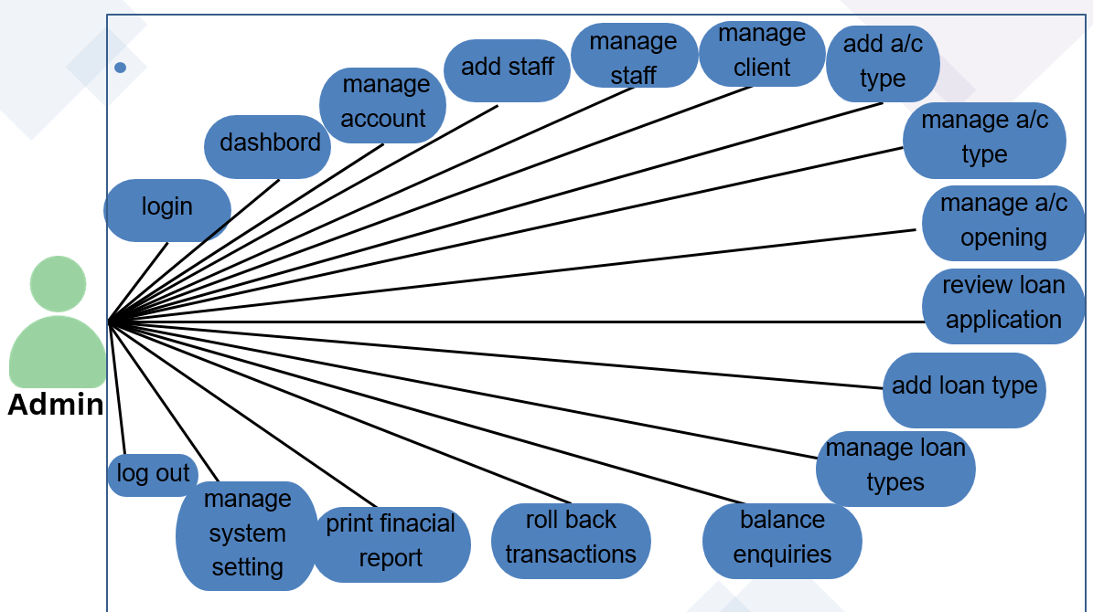

* **Staff Use Case Diagram:**

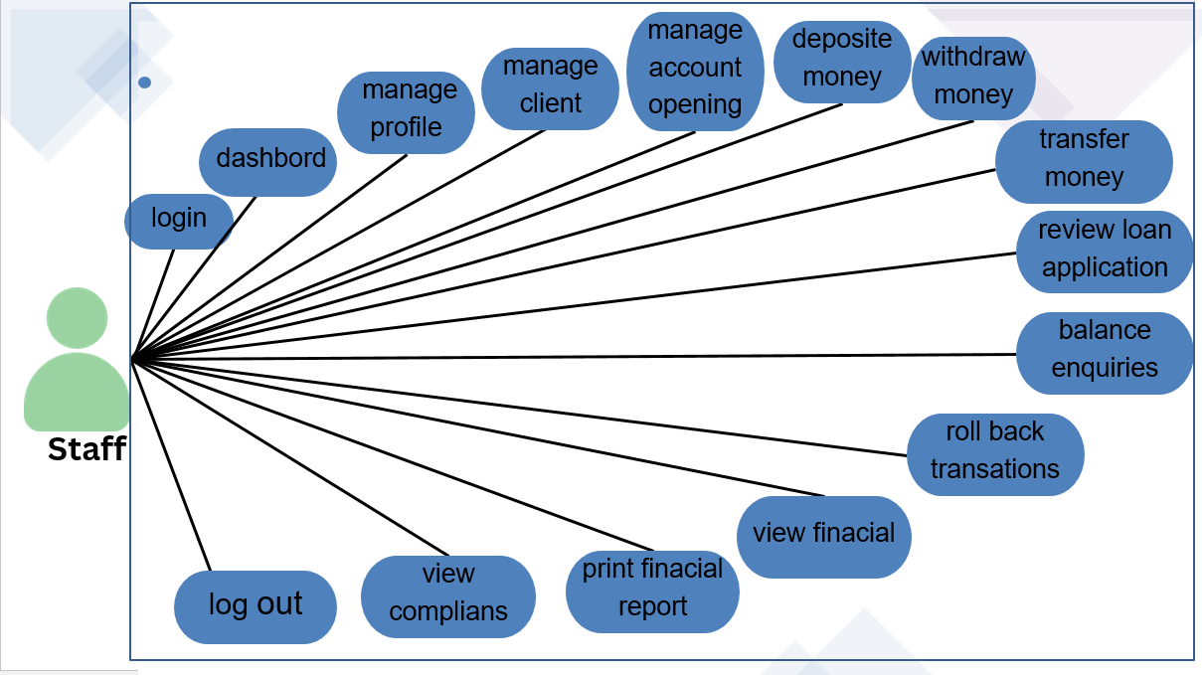**User Use Case Diagram:**

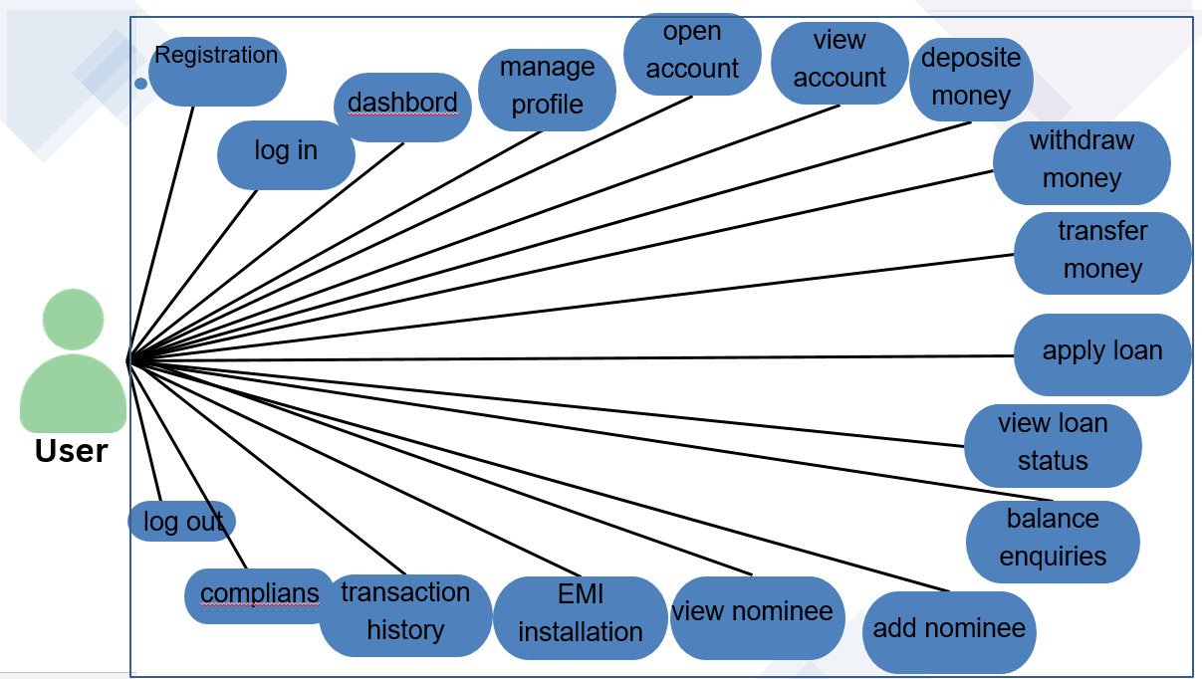

**5.2 Activity Diagram**

* **Activity Diagram for Super Admin:**



**Admin**



**Login**



**Check EmailID & Password**



**Logged On**



**Forgot Password**



**Validate Data**



**Manage Staff**



**Manage Clients**



**Manage Account Type**



**Manage Loans**



**Change Password & Profile**



**Manage System Settings**



**Transaction History**



**Financial Reports**



**Deposit Interest**



**Balance Enquiries**



**Logout**



**1**

**5**

**4**

**3**

**2**

**6**

**7**

**8**

**9**

**Y**

**N**

**N**

**Y**

* **Activity Diagram for Admin – Staff Management:**

**1**



**Manage Staff**



**Add New**

**Staff**



**View Staff**



**Enable/Disable**

**Staff**



**Edit Staff**



**Error**



**Error**



**Error**

**Valid**

**Data?**

**Valid**

**Data?**

**Valid**

**Data?**



**Staff Added**



**Staff Updated**



**Staff**

**Enabled/Disabled**

**End**

**No**

**N**

**N**

**Yes**

**Yes**

**Yes**

* **Activity Diagram for Admin – Client Management:**

**2**



**Manage Clients**



**View Clients**



**Enable/Disable**

**Staff**



**Edit Staff**



**Error**



**Error**

**Valid**

**Data?**

**Valid**

**Data?**



**Staff Updated**



**Staff**

**Enabled/Disabled**

**End**

**N**

**N**

**Yes**

**Yes**

* **Activity Diagram for Admin – Account Type Management:**

**3**



**Manage Account Type**



**Add New**

**Acc Type**



**View Accounts**



**Enable/Disable**

**Acc Type**



**Edit Acc Type**



**Error**



**Error**



**Error**

**Valid**

**Data?**

**Valid**

**Data?**

**Valid**

**Data?**



**Acc Type Added**



**Acc Type Updated**



**Acc Type**

**Enabled/Disabled**

**End**

**No**

**N**

**N**

**Yes**

**Yes**

**Yes**

* **Activity Diagram for Admin – Loan Management:**

**4**



**Manage Loan Type**



**Add New**

**Loan Type**



**View Application**



**Enable/Disable**

**Loan Type**



**Edit Loan Type**



**Error**



**Error**



**Error**

**Valid**

**Data?**

**Valid**

**Data?**

**Valid**

**Data?**



**Loan Type Added**



**Loan Type Updated**



**Loan Type**

**Enabled/Disabled**

**End**

**No**

**N**

**N**

**Yes**

**Yes**

**Yes**

* **Activity Diagram for Admin – Deposit Interest:**



**Deposit Interest**



**Deposit Interest**



**Error**

**Valid Data?**



**Deposit Successfully**

**End**

**No**

**Yes**

**5**

* **Activity Diagram for Admin – Balance Enquiries:**



**Balance Enquiries**



**Check Balance**



**Error**

**Valid Data?**



**View Balance**

**End**

**No**

**Yes**

**6**

* **Activity Diagram for Admin – Transactions History:**



**Transactions**



**Transactions History**



**View Transactions**

**Valid Data?**



**Rollback Transaction**

**End**

**No**

**Yes**

**7**

* **Activity Diagram for Admin – Financial Reports:**



**Financial Reports-Deposit**



**CSV Deposit**



**Copy Deposit**



**Print Deposit**



**Excel Deposit**



**Generate**

**CSV File**



**Generate**

**Excel File**



**Print Data**

**End**



**Copy Data**

**8**

MAM ACTIVITY DIAGRAM OF STAFF PANEL AND CLIENT PANEL IS STILL PENDING FOR EDIT.

**Activity Diagram for Seller:**



* **Activity Diagram for Seller – Product Management:**



* **Activity Diagram for Seller – Demand New Category Management:** 
* **Activity Diagram for Seller – Feedback Management:**



* **Activity Diagram for Seller – Inquiry Management:**



* **Activity Diagram for Seller – Order Management:**
* **Activity Diagram for Seller – Payment Management:**



* **Activity Diagram for Seller – Newsletter Management:**



* **Activity Diagram for Interior Designer:**



* **Activity Diagram for Interior Designer – Project Management:**



* **Activity Diagram for Interior Designer – Customer Request**

**Management:**



* **Activity Diagram for Interior Designer – Feedback Management:**



* **Activity Diagram for Interior Designer – Inquiry Management:**



* **Activity Diagram for Customer:**



* **Activity Diagram for Visitor:**



**6**

Chapter

**System Diagram**

|  |  |
| --- | --- |
| 6.1 | Table Structure |
| 6.2 | Screen Layout |

**6.1 Table Structure**

**Table Name:** client_feedback  
**Use:** It is used to store the information of client_feedback.

|  |  |  |  |
| --- | --- | --- | --- |
| Field | Type | Constraints | Description |
| ID | int(10) | Primary Key (AutoIncrement) | Unique field. |
| client_id | Int(10) | foreign key | Unique field. |
| subject | varchar(255) | Not Null | Specify subject |
| feedback_message | text | Not Null | Specify feedback |
| Submission_date | Timestamp | Current Timestamp | Specify Contact Number. |

**Table Name : ib_acc_types**

**Use :** It is used to store the information of a/c types.

|  |  |  |  |
| --- | --- | --- | --- |
| Field | Type | Constraints | Description |
| acctype_id | int(10) | Primary Key (AutoIncrement) | Unique field. |
| Name | varchar(200) | Not Null | Specify Name. |
| discription | Longtext | Not null | Specify description |
| Rate | Varchar(200) | Not null | Specify rate |
| Is_active | Tinyint(1) | Not null | Specify active |
| Min_balance | Decimal(10,2) | Not null | Specify minimum balance |

**Table Name :** ib_admin

**Use :** It is used to store the information of admin.

|  |  |  |  |
| --- | --- | --- | --- |
| Field | Type | Constraints | Description |
| Admin_id | int(11) | Primary Key (AutoIncrement) | Unique field. |
| Name | varchar(200) | Not Null | Specify Name. |
| email | varchar(200) | Not null | Specify email |
| password | varchar(200) | Not null | Specify password |
| profile_pic | varchar(200) | Not null | Specify profile picture |
| Is_active | Tinyint(1) | Not null | Specify active |
| otp | Varchar(6) | allows null | Specify otp |
| Otp_expiry | Date_time | Allows null | Specify otp expiry |

**Table Name : ib_bankaccounts**

**Use :** It is used to store the information of bankaccounts .

|  |  |  |  |
| --- | --- | --- | --- |
| Field | Type | Constraints | Description |
| account_id | int(11) | Primary Key (AutoIncrement) | Unique field. |
| Acc_Name | varchar(200) | Not Null | Specify a/c Name. |
| account_number | varchar(200) | Not null | Specify a/c number |
| Acc_type_id | varchar(200) | foreign key (allows null) | Specify acc type |
| Acc_rate | varchar(200) | Not null | Specify acc rate |
| Acc_status | varchar(200) | Not null | Specify acc status |
| Acc_amount | varchar(200) | Not null | Specify a/c amount |
| client_id | int(10) | foreign key | Specify client id |
| Created-at | timestamp | not null | Specify created-at |
| Is_active | Tinyint(1) | Not null | Specify active |

**Table Name : ib_clients**

**Use :** It is used to store the information of client .

|  |  |  |  |
| --- | --- | --- | --- |
| Field | Type | Constraints | Description |
| client_id | int(11) | Primary Key (AutoIncrement) | Unique field. |
| Name | varchar(200) | Not Null | Specify Name. |
| phone | varchar(200) | Not null | Specify phone |
| Adress | varchar(200) | Not null | Specify adress |
| Email | varchar(200) | Not null | Specify email |
| Adhar_number | varchar(200) | Not null | Specify adhar_number |
| Pan_number | varchar(200) | Not null | Specify pan_number |
| password | varchar(200) | Not null | Specify password |
| Profile_pic | Varchar(200) | not null | Specify profile picture |
| Is_active | Tinyint(1) | Not null | Specify active |
| otp | Varchar(6) | allows null | Specify otp |
| Otp_expiry | Datetime | Allows null | Specify otp expiry |

**Table Name : ib_nominees**

**Use :** It is used to store the information of nominees .

|  |  |  |  |
| --- | --- | --- | --- |
| Field | Type | Constraints | Description |
| id | int(11) | Primary Key (AutoIncrement) | Unique field. |
| client_id | int(11) | Not null | Specify client id. |
| Nominee_Name | varchar(200) | Not Null | Specify nominee Name. |
| Relation | varchar(200) | Not null | Specify |
| Nominee_Email | varchar(200) | Not null | Specify nominee email |
| Nominee_phone | varchar(200) | Not null | Specify Nominee_phone |
| Nominee_Adress | varchar(200) | Not null | Specify Nominee_adress |
| Is_active | Tinyint(1) | Not null | Specify active |
| Adhar_number | varchar(12) | Not null | Specify adhar_number |
| Pan_number | varchar(10) | Not null | Specify pan_number |

**Table Name :ib_staff**

**Use :** It is used to store the information of staff .

|  |  |  |  |
| --- | --- | --- | --- |
| Field | Type | Constraints | Description |
| staff_id | int(11) | Primary Key (AutoIncrement) | Unique field. |
| Name | varchar(200) | Not Null | Specify Name. |
| phone | varchar(200) | Not null | Specify phone |
| Email | varchar(200) | Not null | Specify email |
| password | varchar(200) | Not null | Specify password |
| Sex | varchar(200) | Not null | Specify sex |
| Profile_pic | Varchar(200) | not null | Specify profile picture |
| otp | Varchar(6) | allows null | Specify otp |
| Otp_expiry | Datetime | Allows null | Specify otp expiry |
| Adhar_number | varchar(12) | Not null | Specify adhar_number |
| Pan | varchar(10) | Not null | Specify pan_number |

**Table Name :ib_systemsetting**

**Use :** It is used to store the information of **systemsettin**

|  |  |  |  |  |
| --- | --- | --- | --- | --- |
| Field | Type | | Constraints | Description |
| Id | int(11) | | Primary Key (AutoIncrement) | Unique field. |
| Sys_Name | longtext | | Not Null | Specify name. |
| Sys_lageline | longtext | | Not null | Specify tageline |
| Sys_logo | Varchar(200) | | Not null | Specify logo |
| Is_active | | Tinyint(1) | Not null | Specify active |

**Table Name :ib_transaction**

**Use :** It is used to store the information of **transaction** .

|  |  |  |  |  |  |  |
| --- | --- | --- | --- | --- | --- | --- |
| Field | | Type | | Constraints | | Description |
| tr_id | | int(11) | | Primary Key (AutoIncrement) | | Unique field. |
| code | Varchar(200) | | Not null | | Specify code | |
| account_id | | int(11) | | foreign key | | Specify account id |
| Tr_type | | Varchar(200) | | Not null | | Specify type |
| Tr_status | | Varchar(200) | | Not null | | Specify status |
| client_id | | Int(10) | | foreign key | | Unique field. |
| transaction_amt | | Varchar(200) | | Not null | | Specify **transaction amt** |
| receiving_acc_no | | Varchar(200) | | Not null | | Specify **receiving acc no** |
| Created-at | | timestamp | | not null | | Specify created-at |
| Is_active | | Tinyint(1) | | Not null | | Specify active |

**Table Name :ib_loan_application**

**Use :** It is used to store the information of **application**.

|  |  |  |  |  |  |  |
| --- | --- | --- | --- | --- | --- | --- |
| Field | | Type | | Constraints | | Description |
| id | | int(10) | | Primary Key (AutoIncrement) | | Unique field. |
| applicant_name | Varchar(255) | | Not null | | Specify code | |
| loan_amount | | decimal(10,2) | | foreign key | | Specify account id |
| Application_date | | datetime | | Not null | | Specify type |
| status | | enum | | Not null | | Specify status |
| Reviewed_by | | Int(11) | | foreign key | | Unique field. |
| admin_review_id | | Int(11) | | foreign key | | Specify **transaction amt** |
| Review_date | | datetime | | Not null | | Specify **receiving acc no** |
| Staff_remark | | text | | not null | | Specify created-at |
| admin_remark | | text | | Not null | | Specify active |
| Client_id | | Int(10) | | foreign key | | Specify cid |
| Loan_type_id | | Int(11) | | foreign key | | Specify loan_type_id |
| is_approved_by_staff | | Tinyint(1) | | None | | Specify staff |
| income_salary | | Decimal(10,2) | | None | | Specify income |
| loan_duration_years | | Int(11) | | None | | Specify loan |
| |  |  | | --- | --- | | **loan_duration_months** |  | | | Int(11) | | none | | Specify duration |

**Table Name : loan_payments**

**Use :** It is used to store the information of **loan_payments** .

|  |  |  |  |  |  |  |
| --- | --- | --- | --- | --- | --- | --- |
| Field | | Type | | Constraints | | Description |
| id | | int(10) | | Primary Key (AutoIncrement) | | Unique field. |
| Client_id | int(10) | | foreign key | | Specify client id | |
| loan_id | | int(10) | | foreign key | | Specify loan id |
| emi_date | | date | | foreign key | | Specify emi date |
| amount | | Decimal(10.2 | | Not null | | Specify amount |
| status | | enum | | Not_null | | Specify status. |
| Created_at | | timestamp | | Not null | | Specify **created at** |

**Table Name : loan_types**

**Use :** It is used to store the information of loan type .

|  |  |  |  |  |  |  |
| --- | --- | --- | --- | --- | --- | --- |
| Field | | Type | | Constraints | | Description |
| id | | int(10) | | Primary Key (AutoIncrement) | | Unique field. |
| type_name | Varchar(100) | | Not null | | Specify type_name | |
| description | | text | | foreign keyclient | | Specify description |
| interest_rate | | Decimal(5,2) | | Not null | | Specify rate |
| Max_amount | | Decimal(15,2) | | Not null | | Specify amount |
| Created_at | | Timestamp | | foreign key | | Unique field. |
| Is_active | | tinyInt(11) | | Not null | | Specify active |

**Table Name : password_reset**

**Use :** It is used to store the information of loan types.

|  |  |  |  |  |  |  |
| --- | --- | --- | --- | --- | --- | --- |
| Field | | Type | | Constraints | | Description |
| id | | int(10) | | Primary Key (AutoIncrement) | | Unique field. |
| Admin_id | int(10) | | foreign key | | Specify admin_id | |
| token | | Varchar(64) | | Not null | | Specify token |
| expiry | | datetime | | Not null | | Specify expiry |

**Table Name : lnterest_log**

**Use :** It is used to store the information of interest log .

|  |  |  |  |  |  |  |
| --- | --- | --- | --- | --- | --- | --- |
| Field | | Type | | Constraints | | Description |
| id | | int(10) | | Primary Key (AutoIncrement) | | Unique field. |
| Month_year | Varchar(7) | | foreign key | | Specify month and year | |
| Deposited_by | | Int(11) | | foreign keyclient | | Specify deposited by |
| Created_at | | datetime | | Not null | | Specify created at |

**6.2 Screen Layout**

* **Admin Side:**

**Login:-**

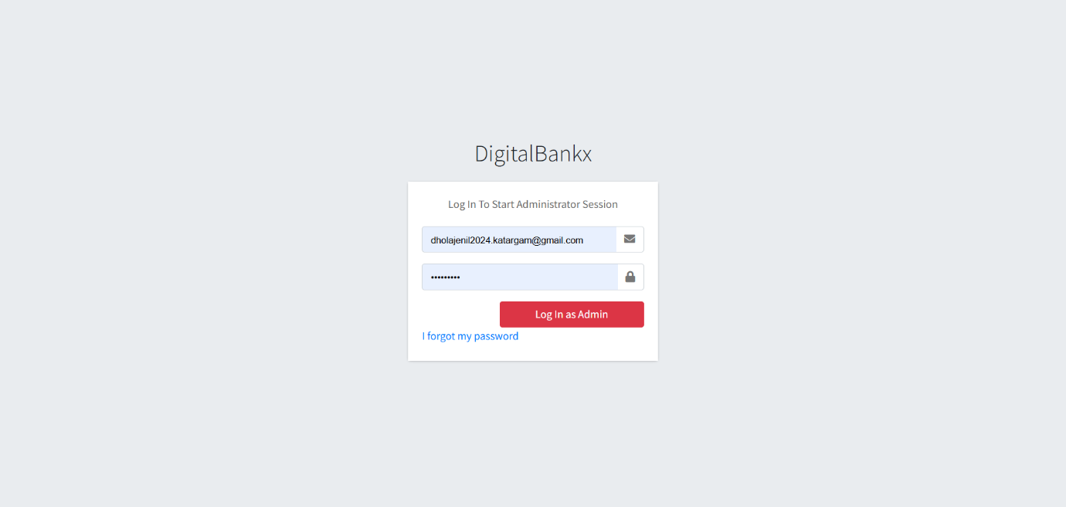

* In this page admin can login in to own website for authentication check.
* In any situation admin forgot the password they can get password on registered mail it will display on next page.

* **Forget Password:-**

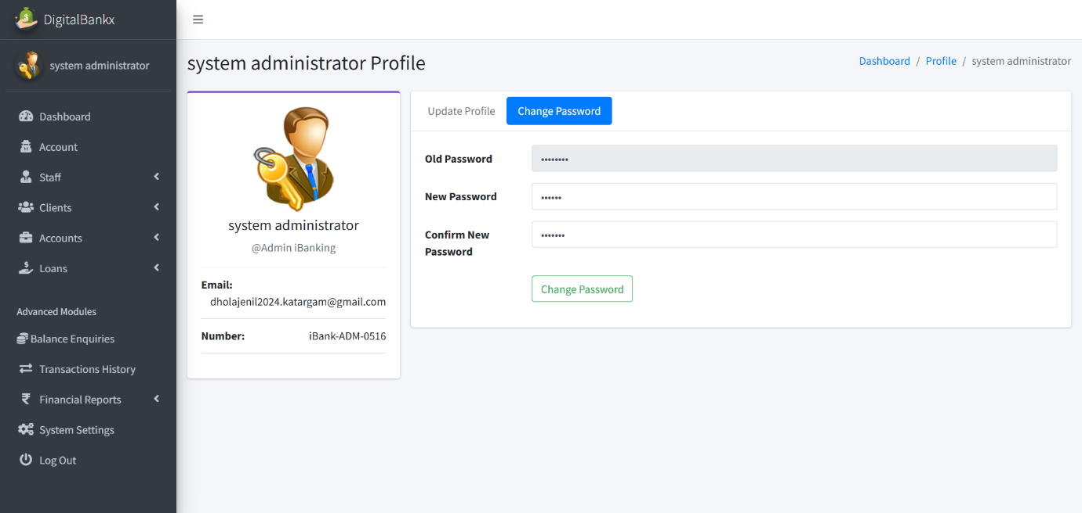

* Admin get their Forgot password through email and if they want to change it they can change password after login

**Dashboard:-**

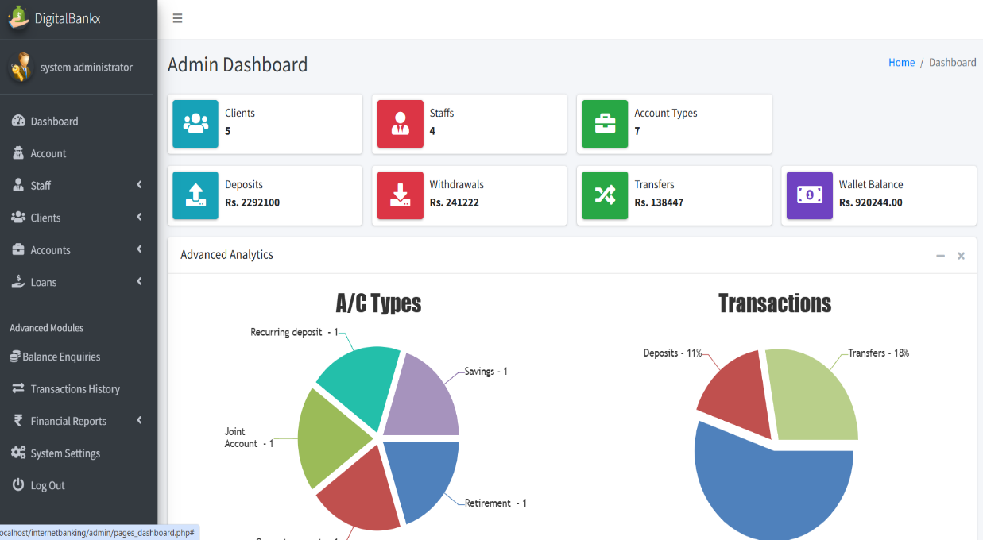

* In this Page admin can see the Dash Board, how many clients,staff, a/c types,deposits, withdrawlas ,transfer ,wallet balance

**Admin update profile:**

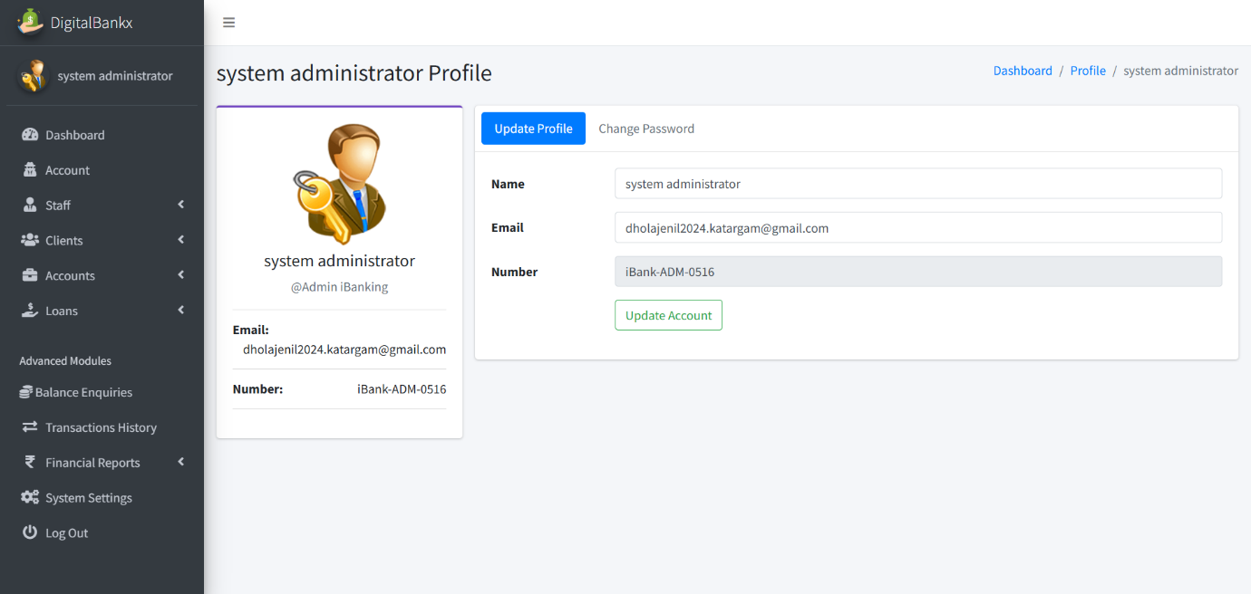

iin

* in this admin can update their profile. For update they have to enter name and email .

**Admin change password :**



* In this page Admin change the password. they have to enter old password and then they have to enter new password and confirm password.

**Change password OTP**

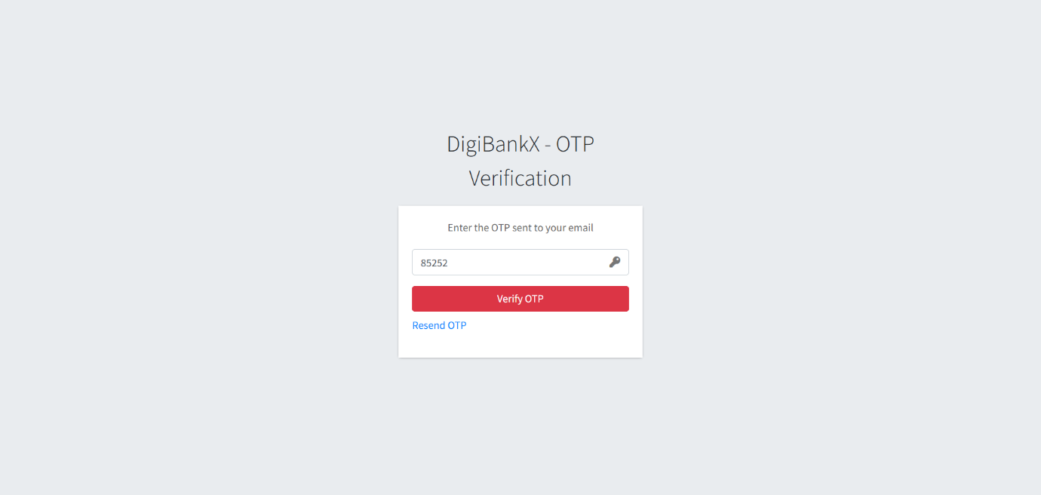

* If you forgot the password we have fasality of change password with OTP verification.

**Create staff :**

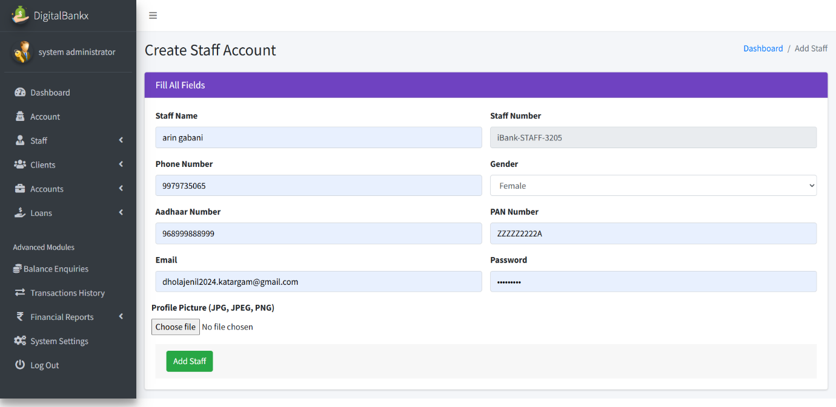

* In this page Admin can create a staff . it can ad staff after enter staff name,mo. Number ,gender , aadhar number , pann number etc.

**staff page:**

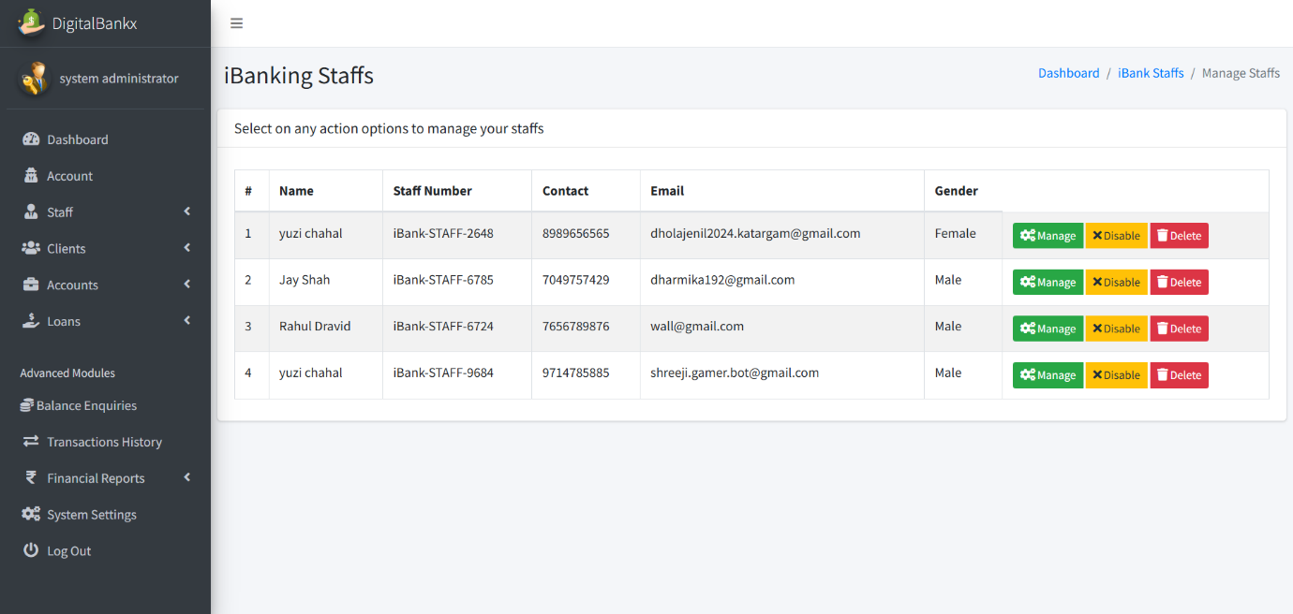

* In this page admin can see the list of staff and also it can disable and delete the staff.
* Admin can active or deactive them.

**manage staff :**

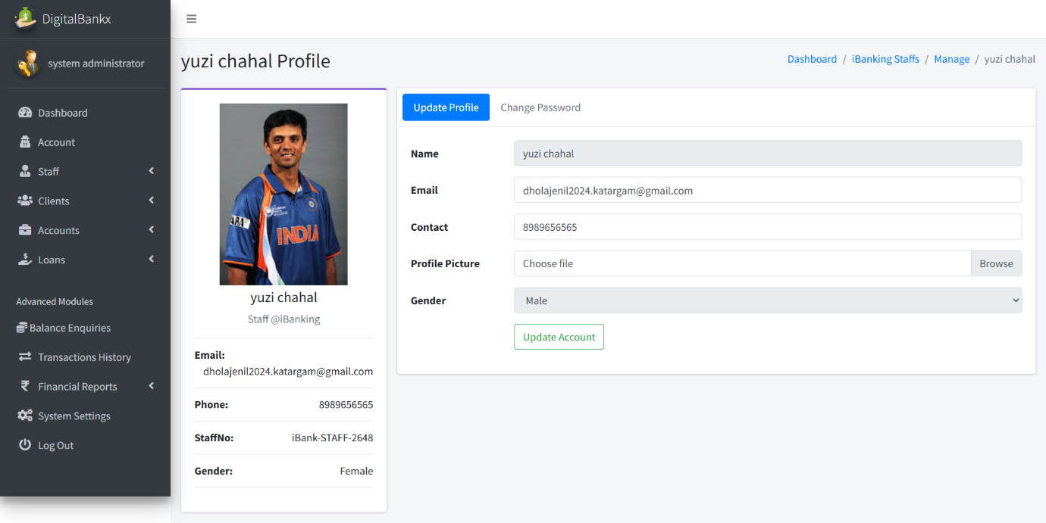

* In this page admin can change staff profile . they can change password also.

**Client page :**

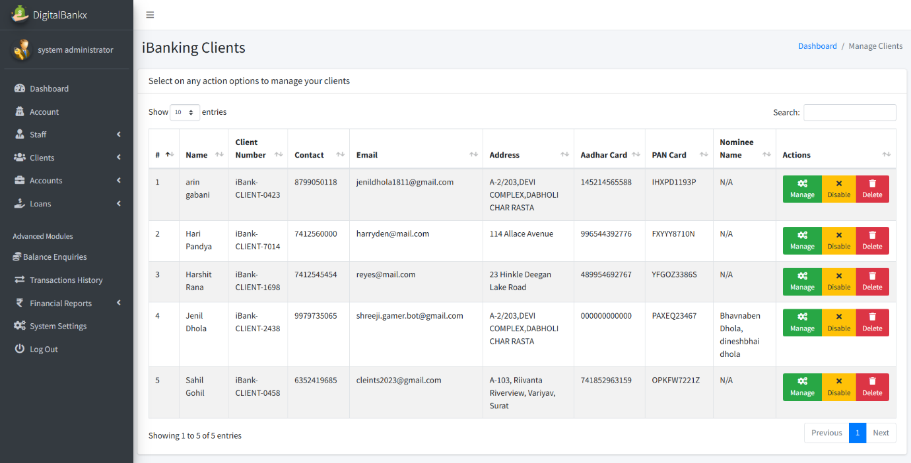

* In this Page admin can see list of clients. Admin can mange , disable and delete the staff.
* Admin can disable and enable the client.

**Manage clients :**

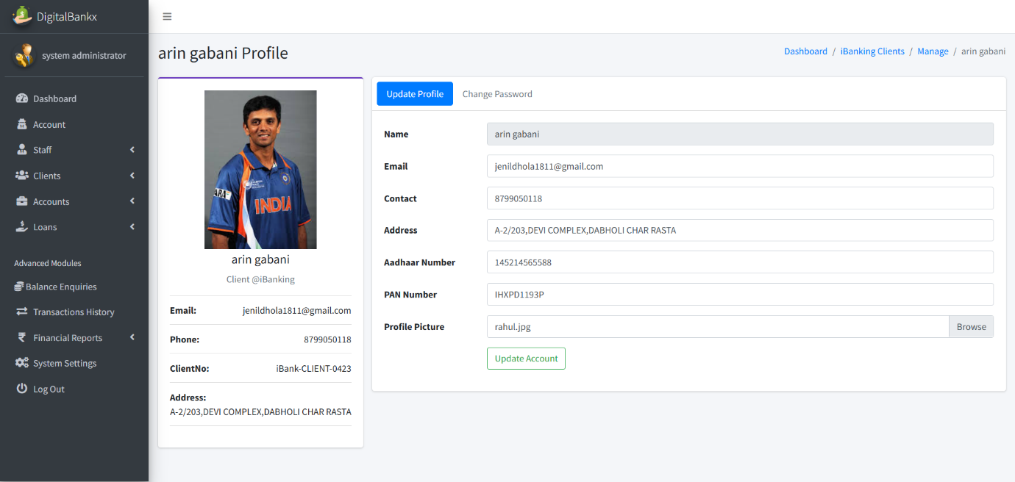

* In this page admin can update the profile of clients.
* Admin can change the pass word of clients.

**Create account categories :**

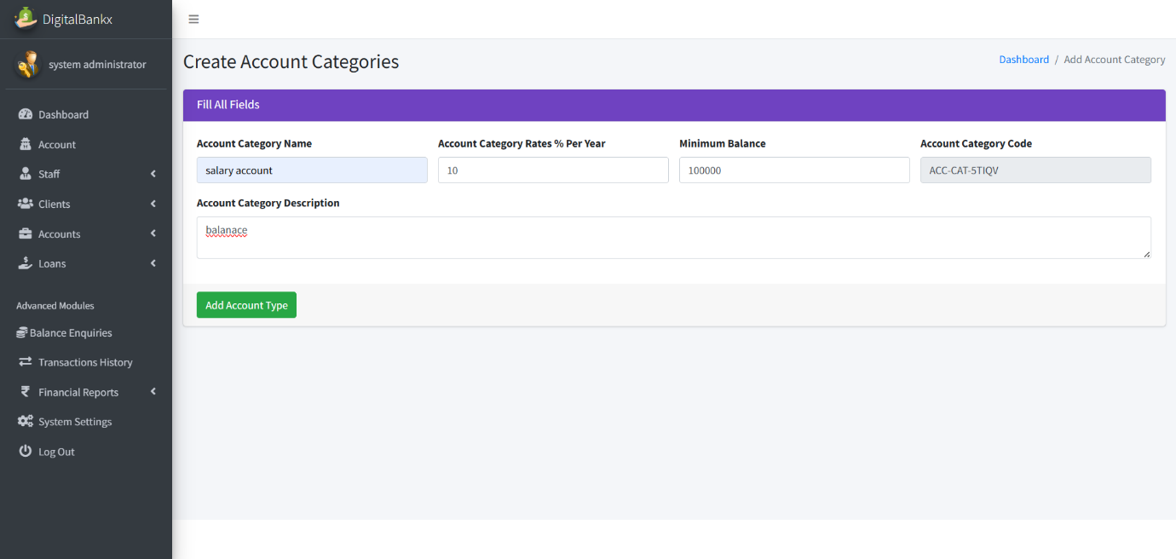

* In this page admin create the account categories by add name , rates , min balance of it .

**Manage a/c type:**

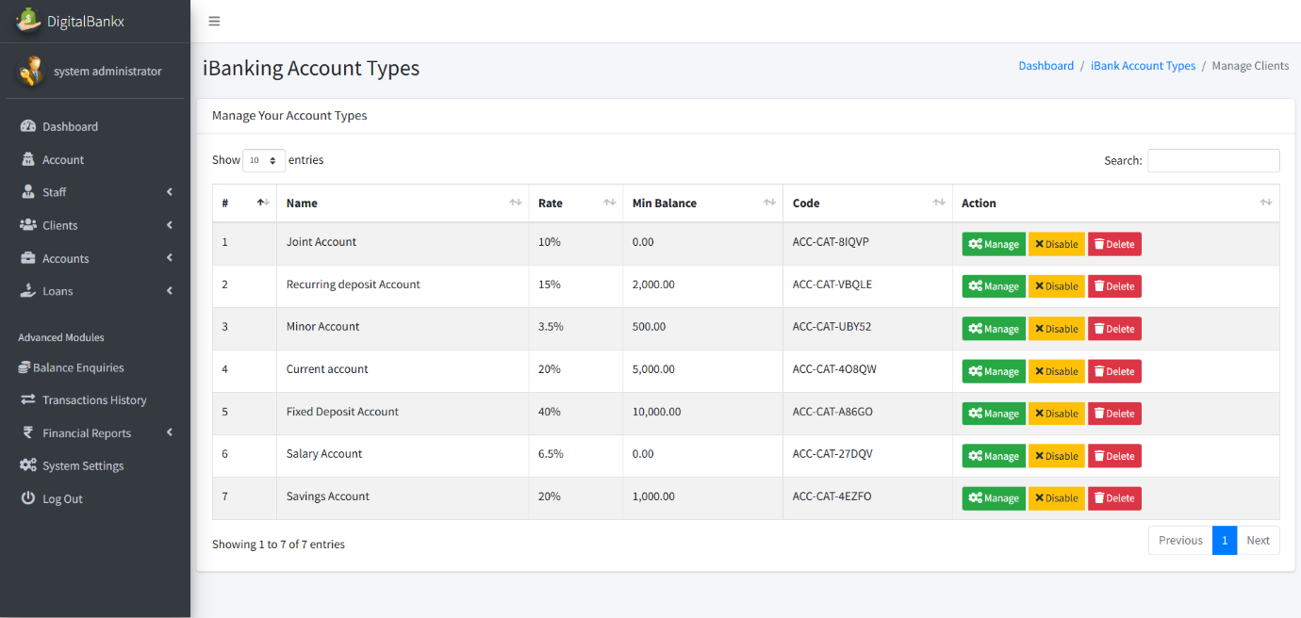

* In this Page admin can see list of account types .
* Admin can manage disable and delete the types.

**Update category name :**

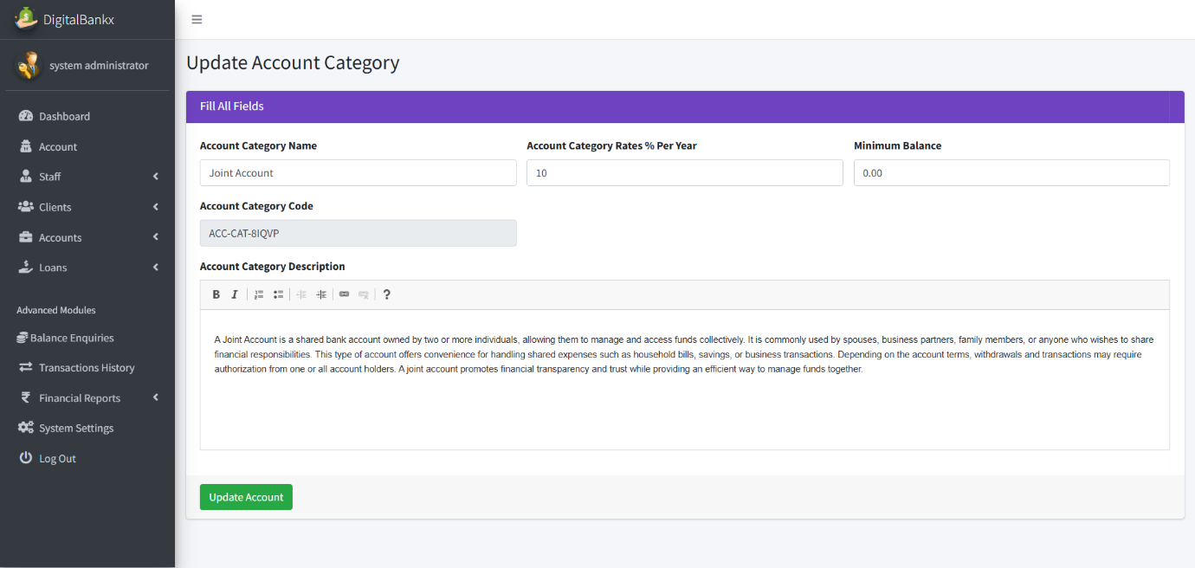

In this page admin can update account category.

**Manage a/c :**

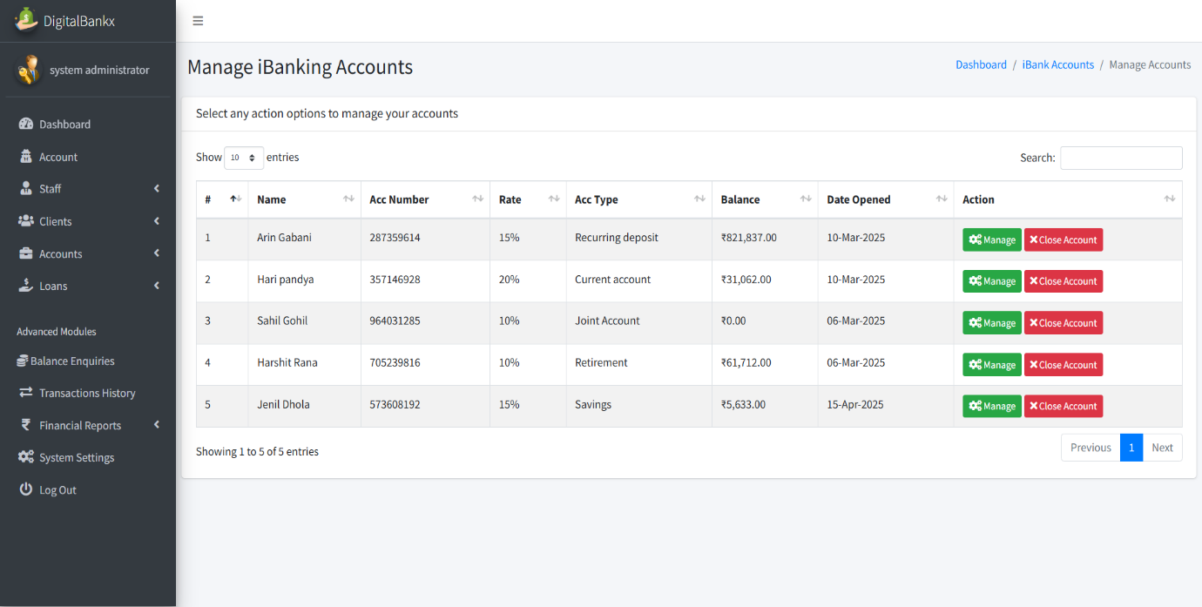

* In this page admin can see list of a accounts.
* Admin can manage and close account

**update a/c type :**

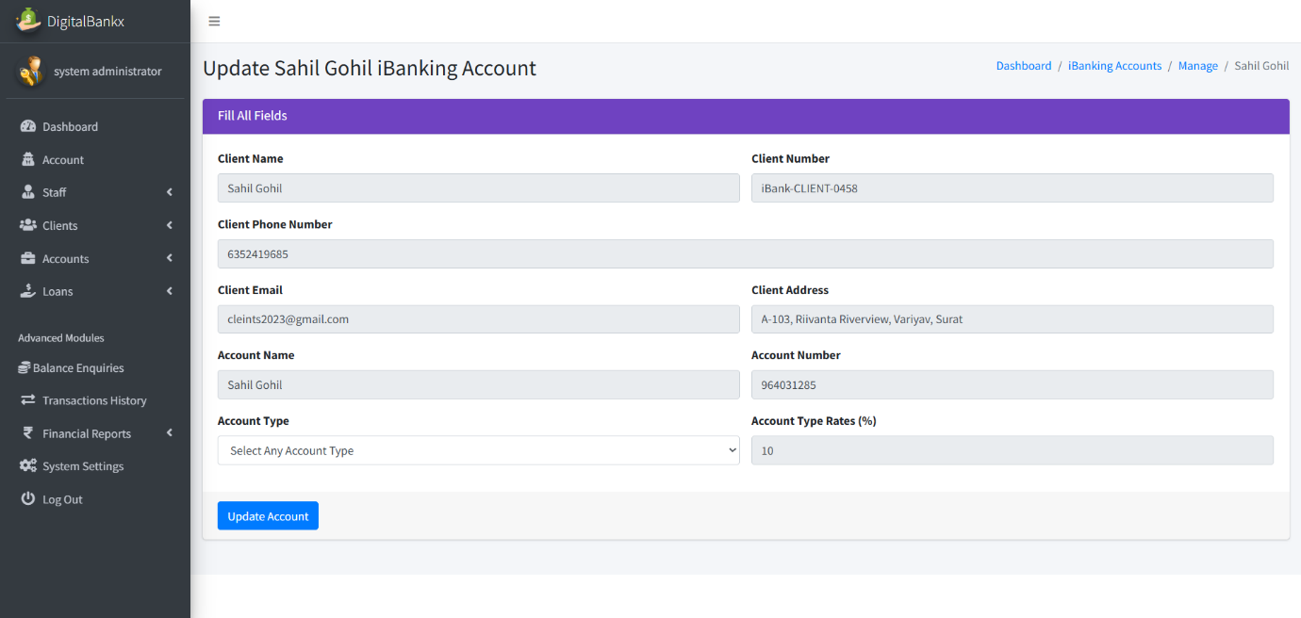

* In this page admin can update the clients account
* Admin can convert the account type .

**Loan application:**

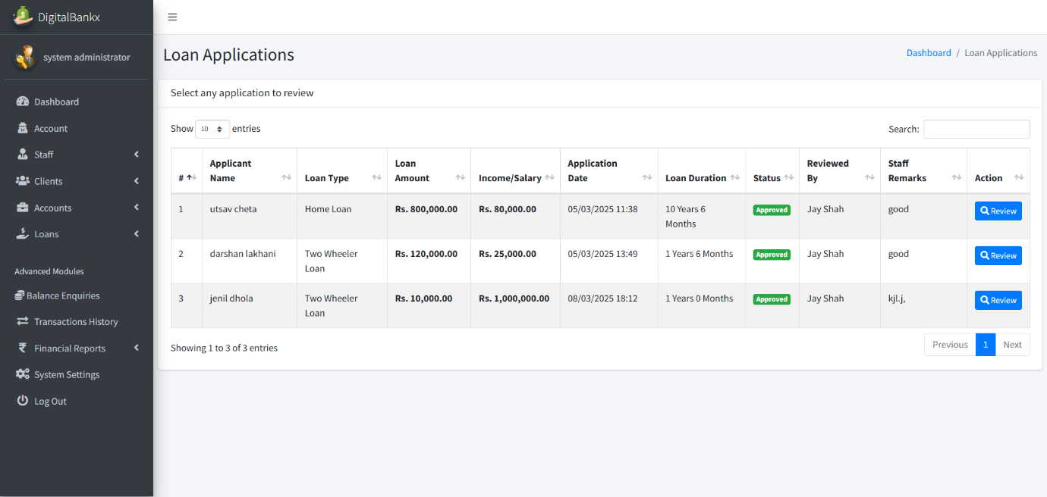

* In this page admin can see list of loan application and see its status also.

**Review loan application:**

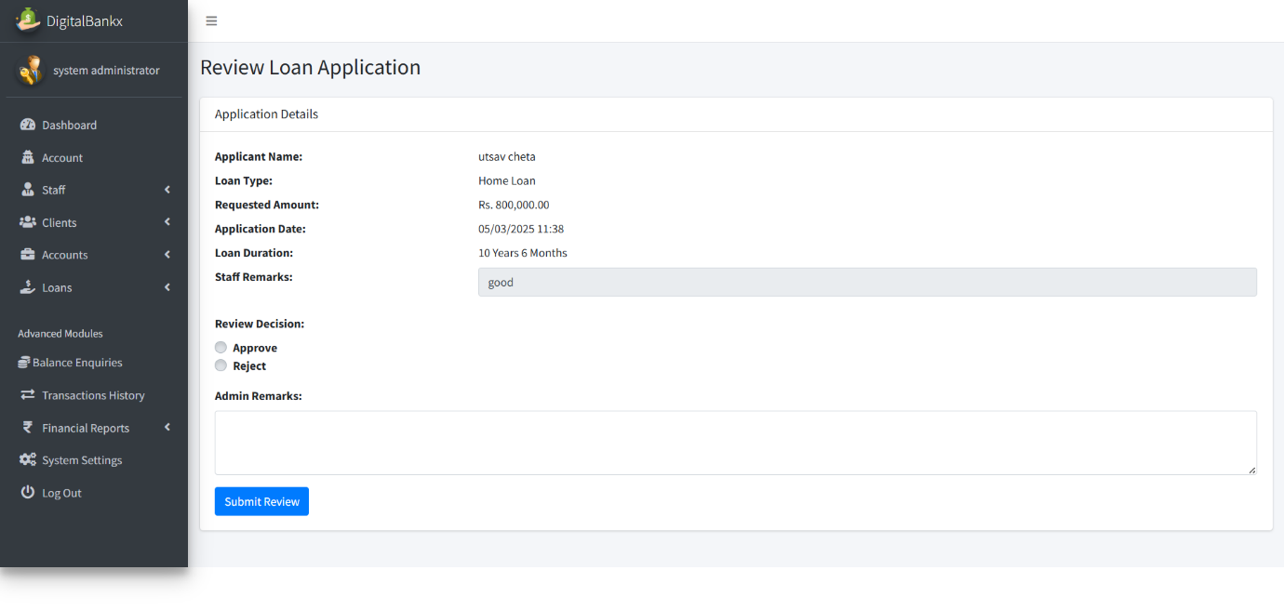

* In this page admin can review loan application.
* Admin also approve or reject the loan.

**Add loan type :**

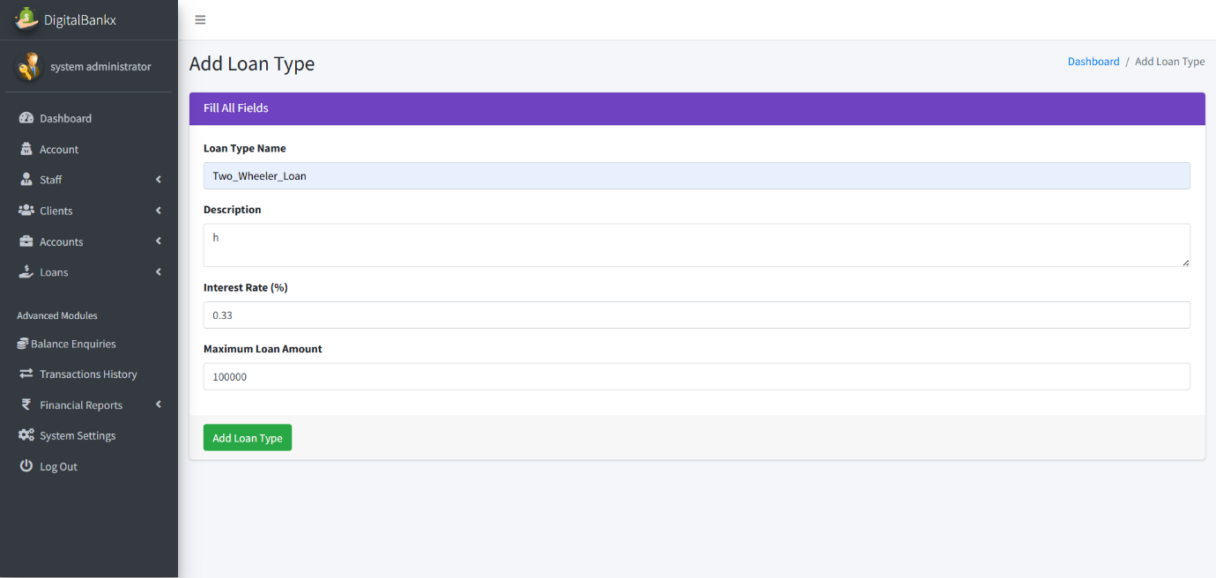

In this page admin can add loan type by add loan type name,description and max amount .

**Edit loan type:**

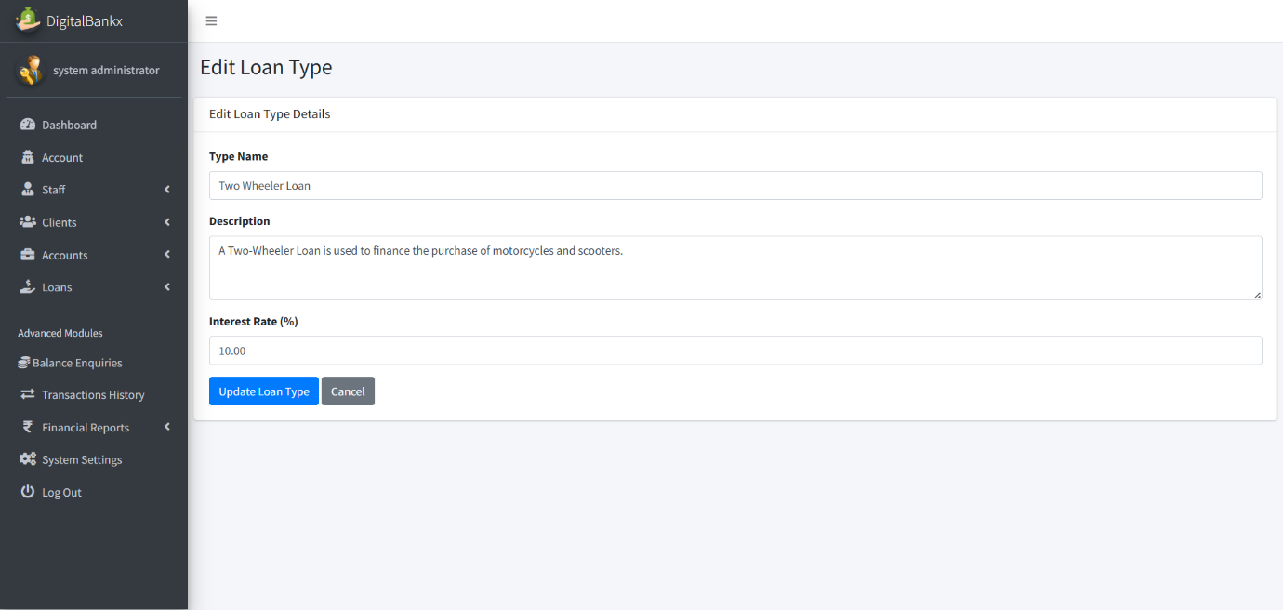

* In this page admin can edit the loan type .

**Balance enquiries:**

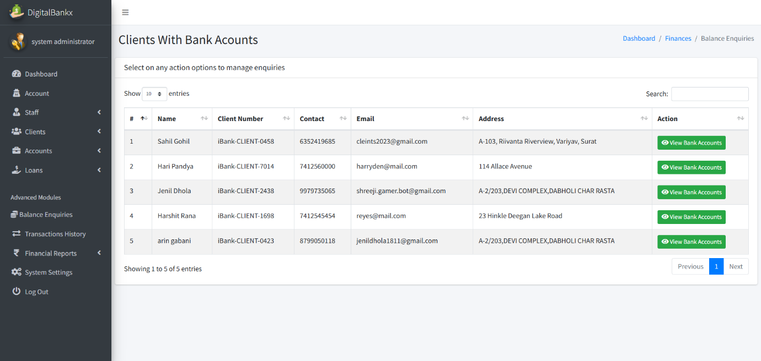

* In this page admin can see list of clients account .

**Check balance:**

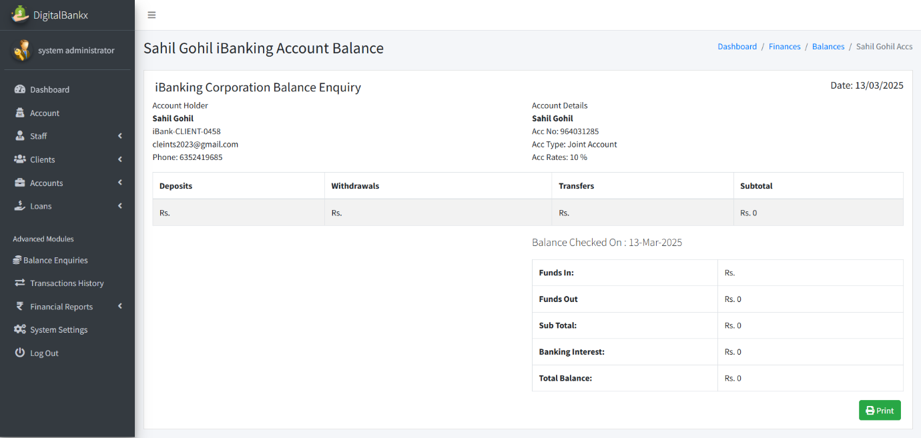

* In this page admin can see account balance .
* Admin can also see the total funds in and out.

**Transaction history :**

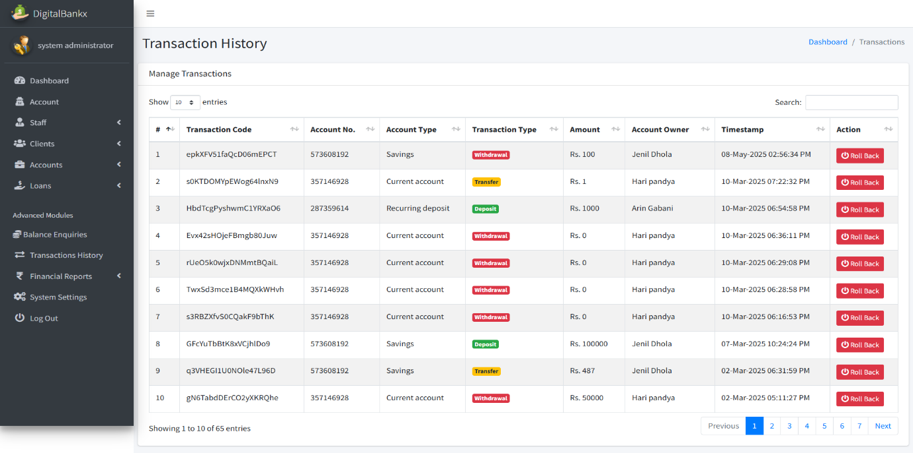

* In this page admin can see the whole transaction history .

**Deposite report:**

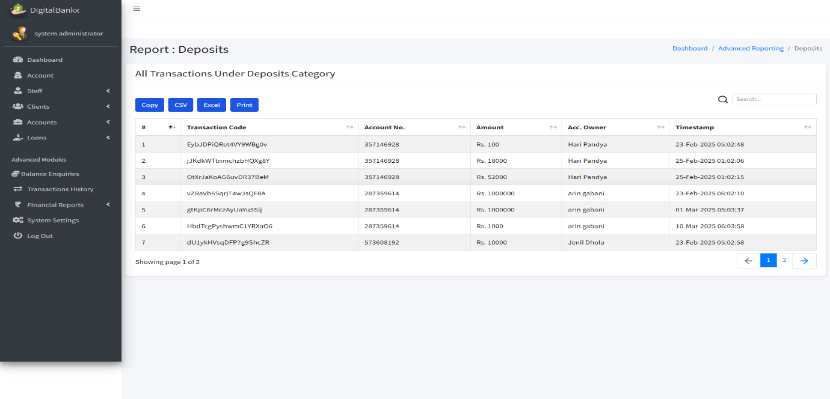

* In this page admin can see the whole history of deposite data.

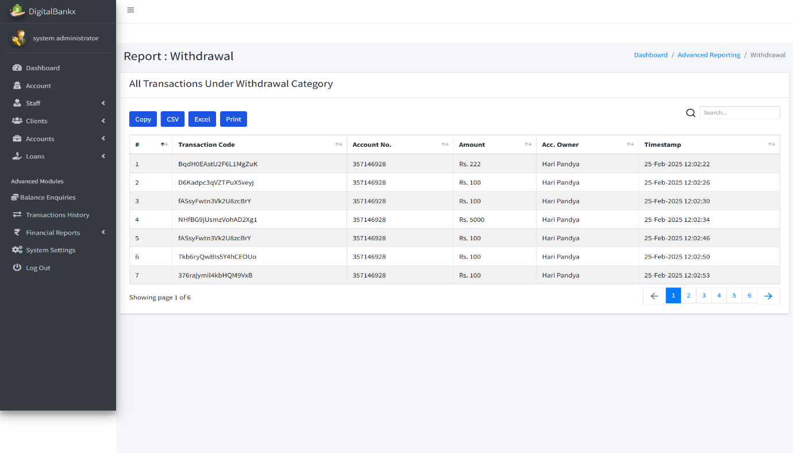**Withdrawal report:**

* In this page admin can see whole withdrawal history .

**Transfer report:**

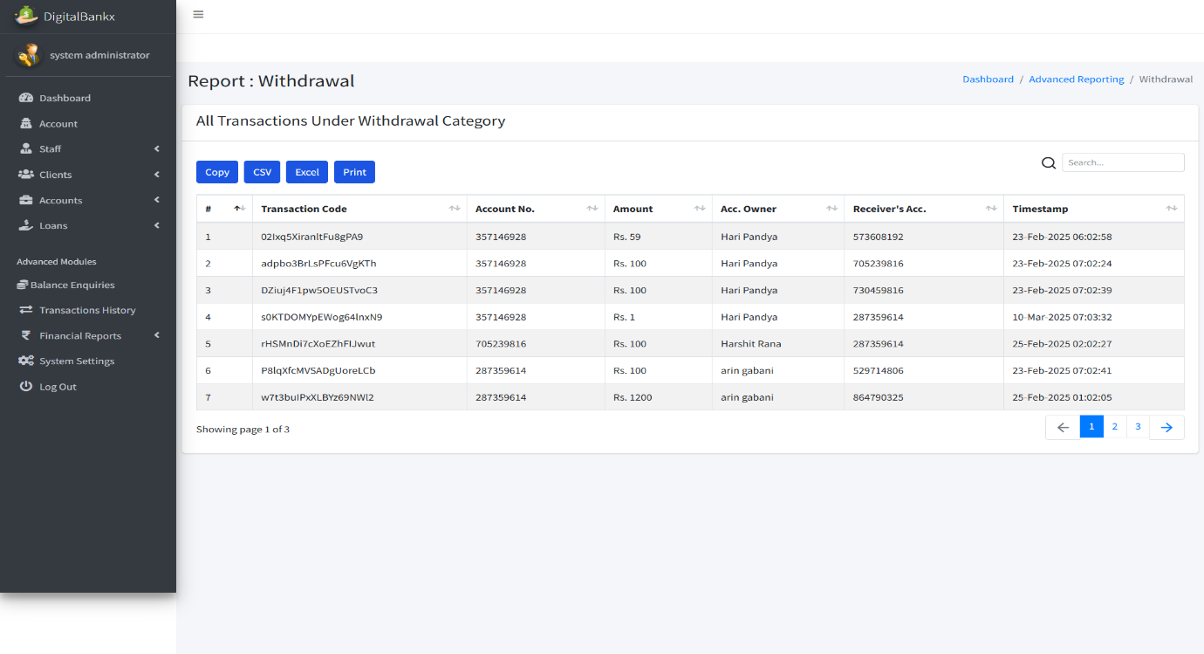

* In this page admin can see whole transfer history .

**System setting :**

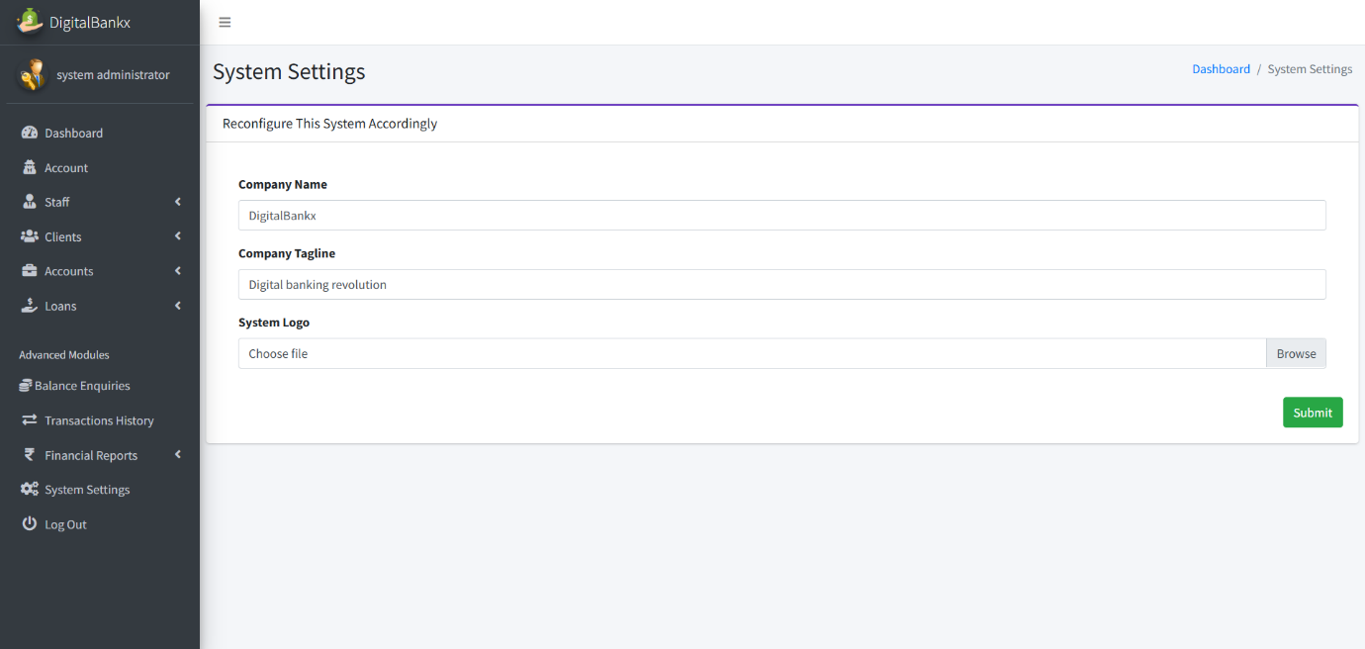

* In this page admin can update the system setting .
* Like company name , company tagline and system logo etc.
* **Staff Side:**

**Staff login:**

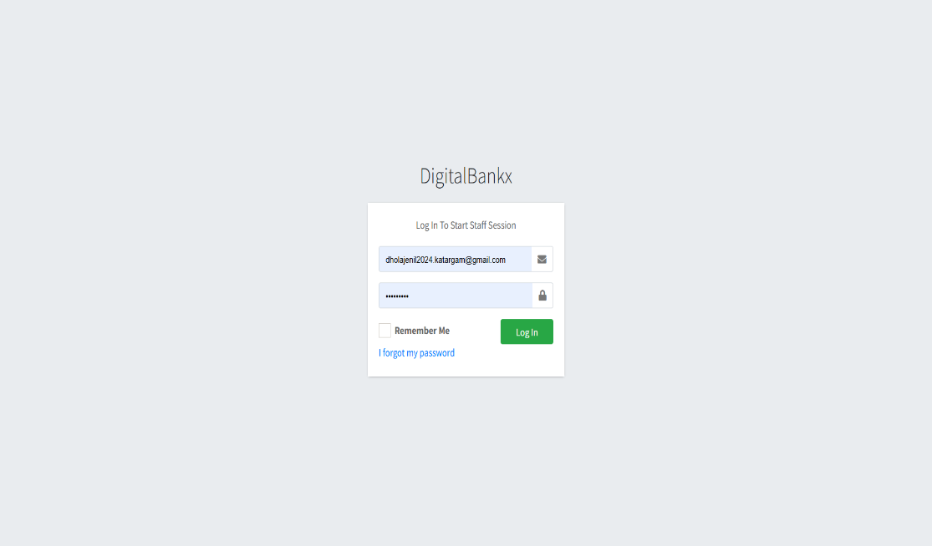

* In this page login to staff session and access the internal system.
* It allows staff members to securely log in using their job functions.

**Staff dashboard:**

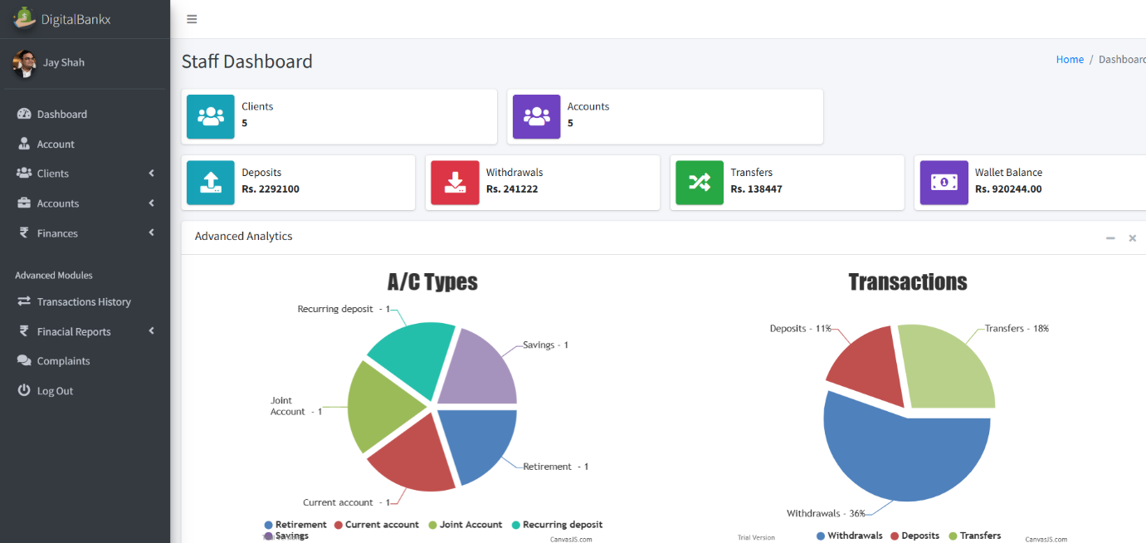

* **in this page access transaction history, complaints, financial reports, and other modules.**
* **View reports and charts on account types and transaction trends.**

**Staff account :**

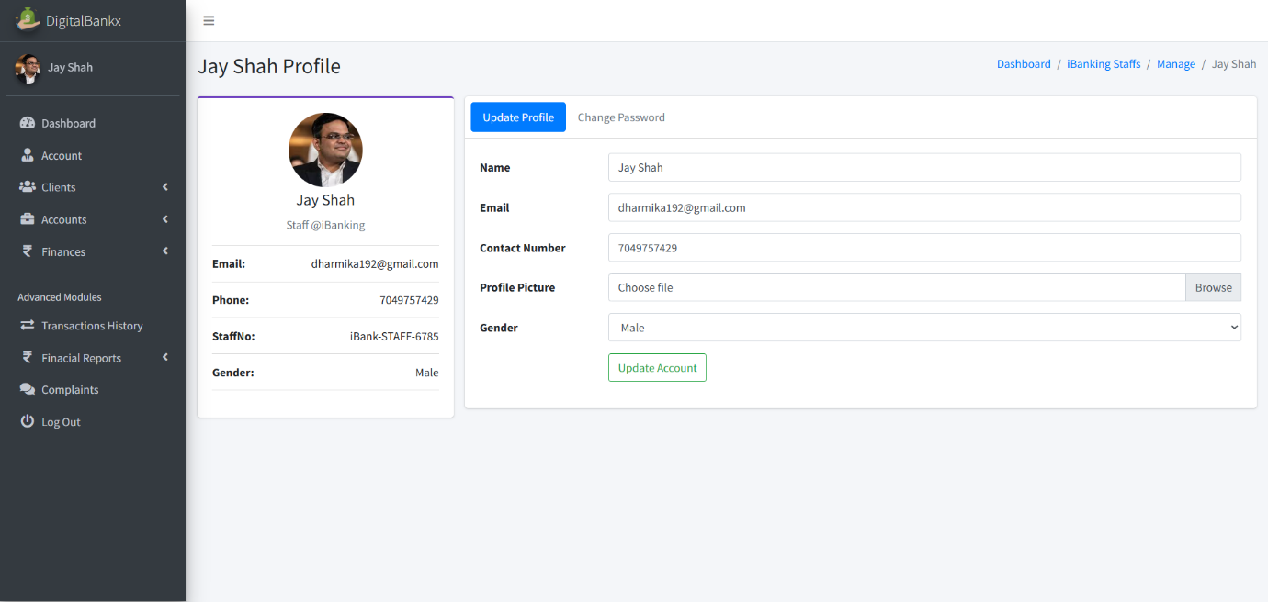

* **In this page staff can update their name, email, contact number and profile picture.**
* **Staff account section is used to mange individual employee profiles within the banking system.**

**IB Clients:**

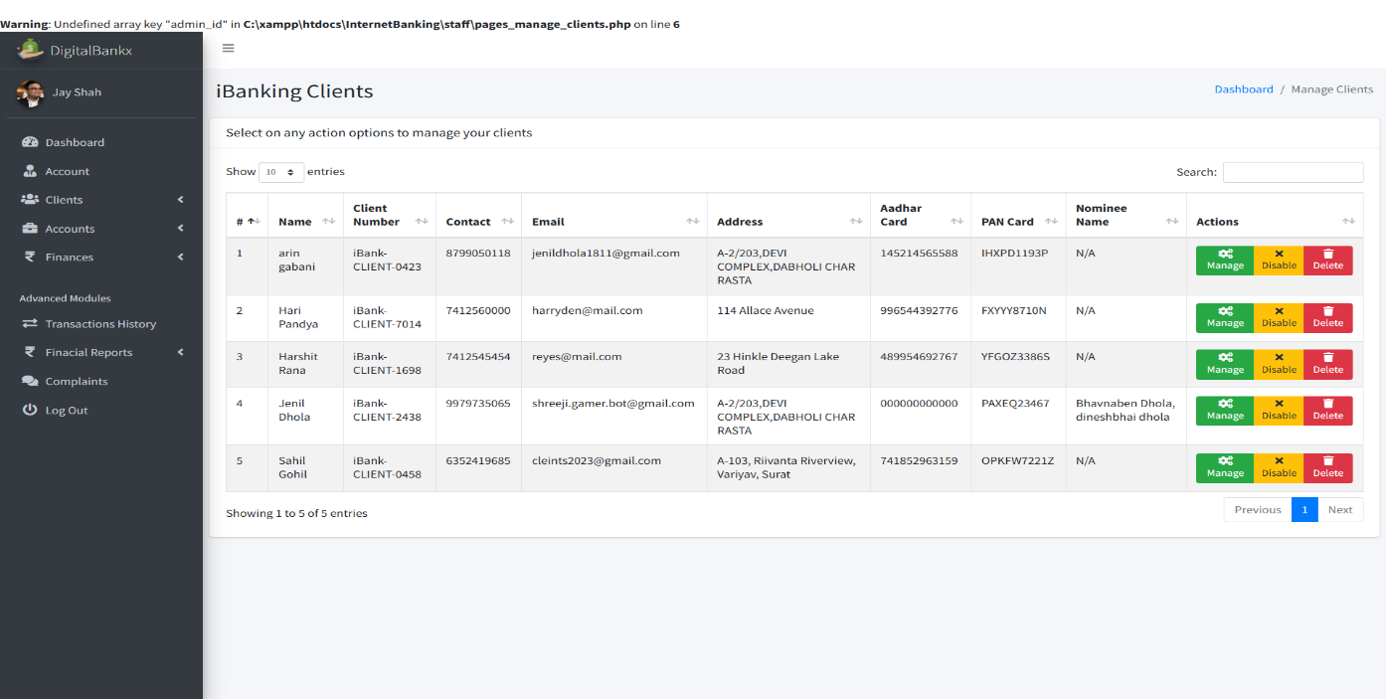

* **In this page use to manage customers who have registered for internet banking.**
* **Account information maintain details like client name, contact, email, address, Aadhaar card, PAN card, etc.**

**Manage client :**

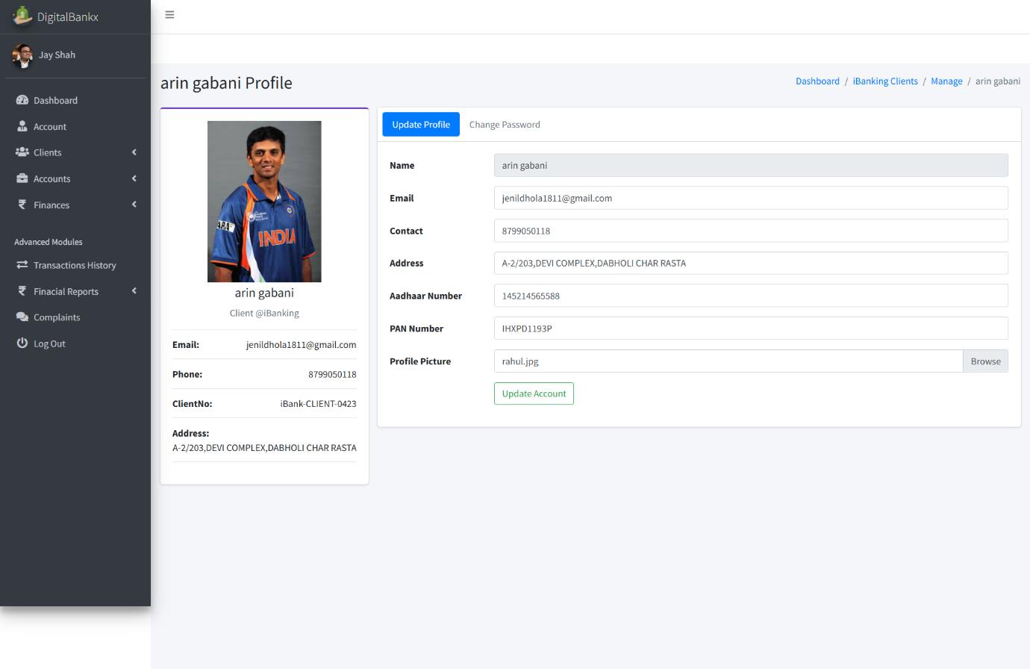

* **In this page use for handing individual customer details.**
* **Change profile pictures and other personal details.**
* **Update details like name, email, phone number, address, Aadhaar number, PAN card, etc.**

**IB account :**

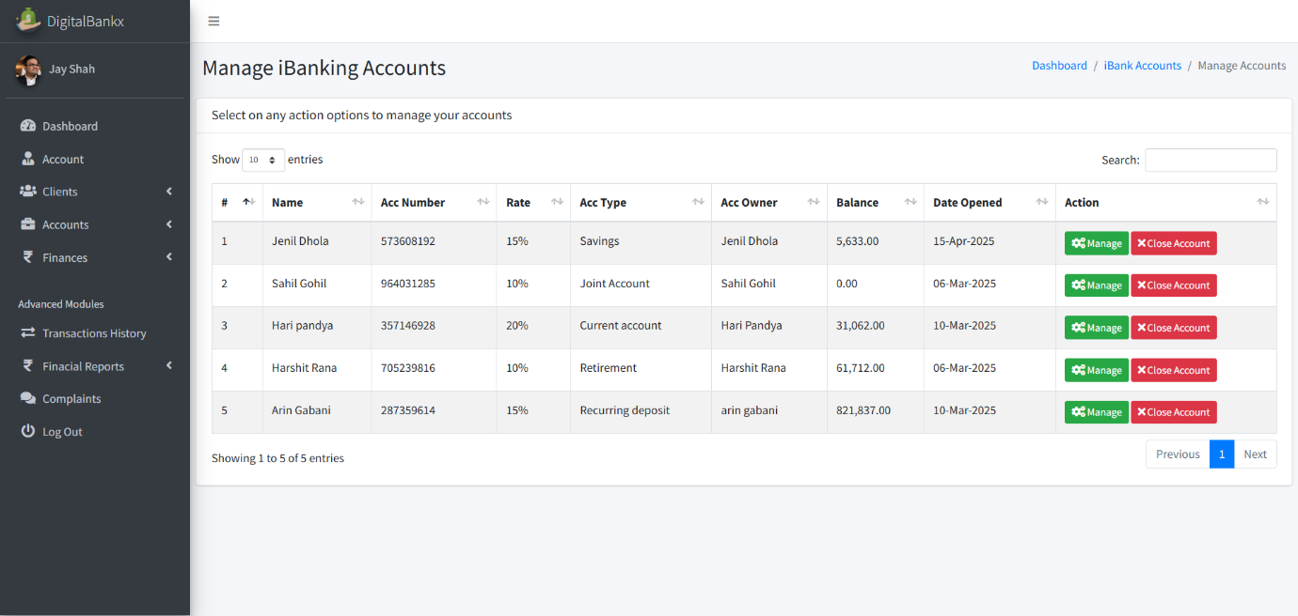

* **In this page used to manage the internet banking accounts of clients.**
* **Handle different types of accounts like savings, current, joint, retirement, and recurring deposit accounts.**

**Manage account:**

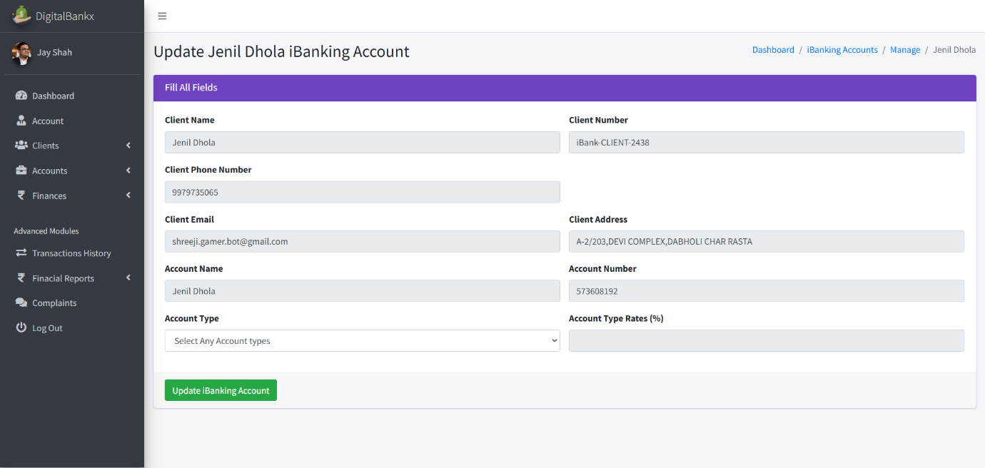

* **In this page used for handling specific internet banking accounts of clients.**
* **Update Client Banking Details to Modify account-related information such as client name, account number, phone number, email, and address.**

**Deposits money:**

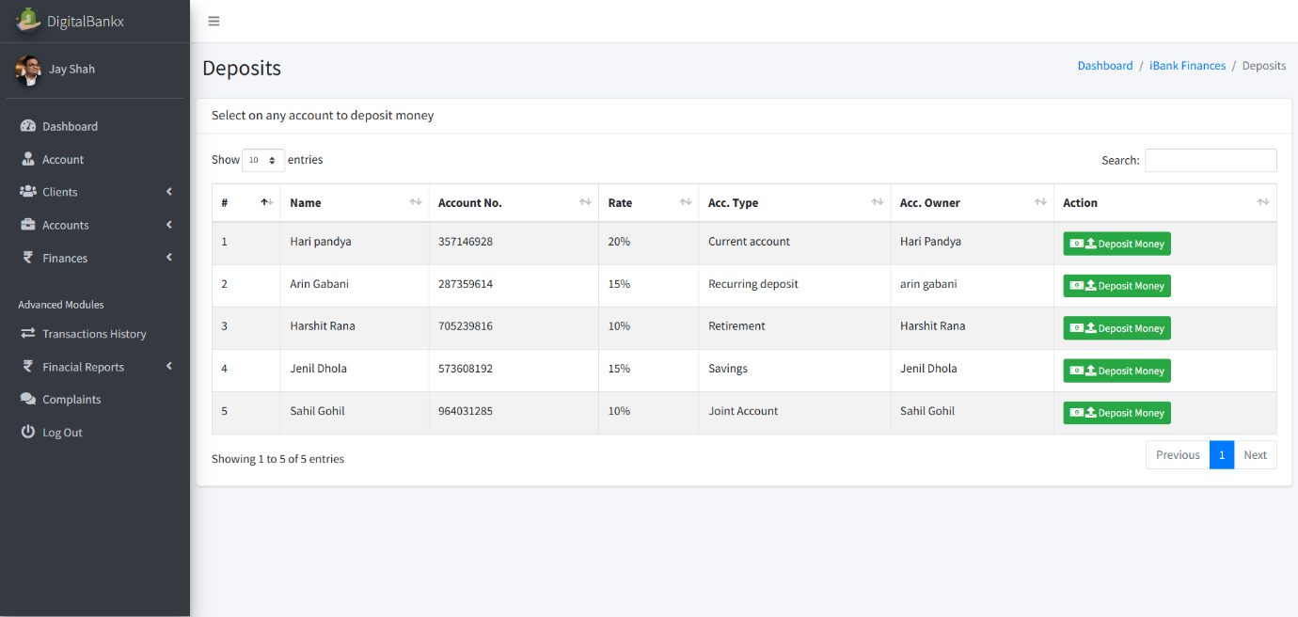

* **In this page use to current account and joint account for deposits money.**
* **Deposits money includes details of multiple accounts money can be deposited.**

**Deposit money:**

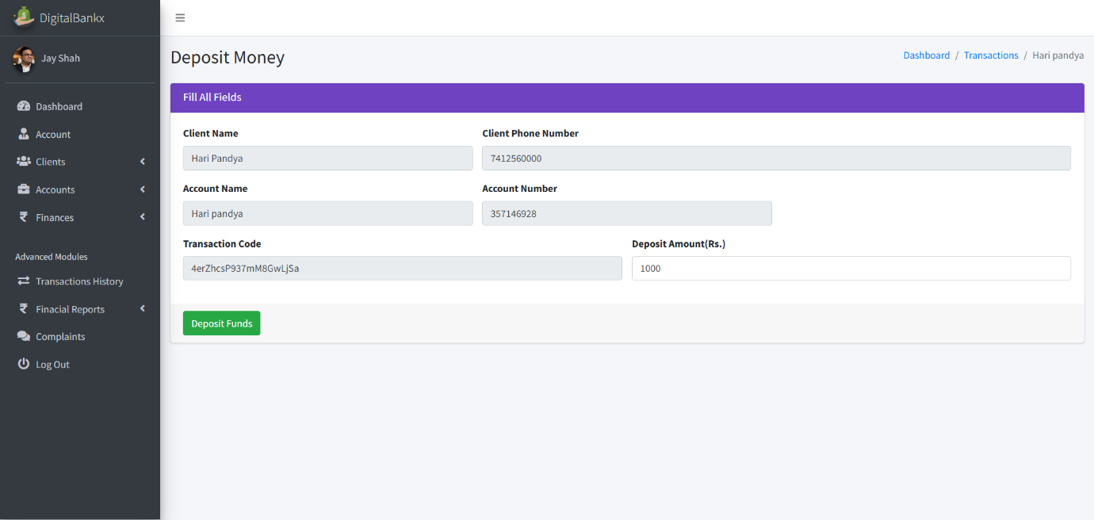

* **In this page deposit is linked to a current account.**

**withdrawals:**

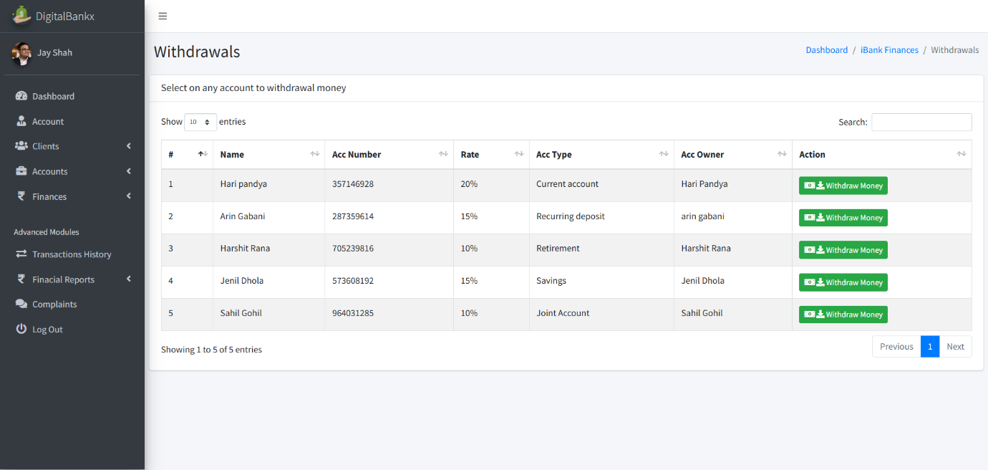

* **In this page withdrawals section allows users to select an account and withdraw funds.**

**Withdraw money:**

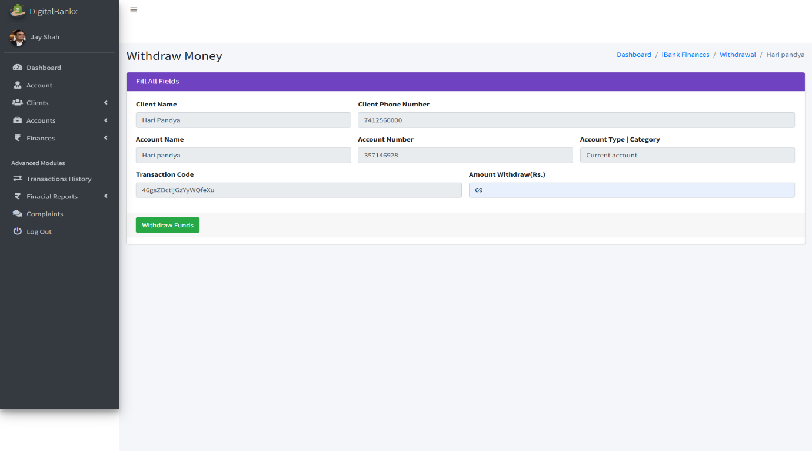

* **In this page allows users to withdraw a specific amount from their account.**
* **transferring it elsewhere or making it available for cash withdrawal.**

**Transfers:**

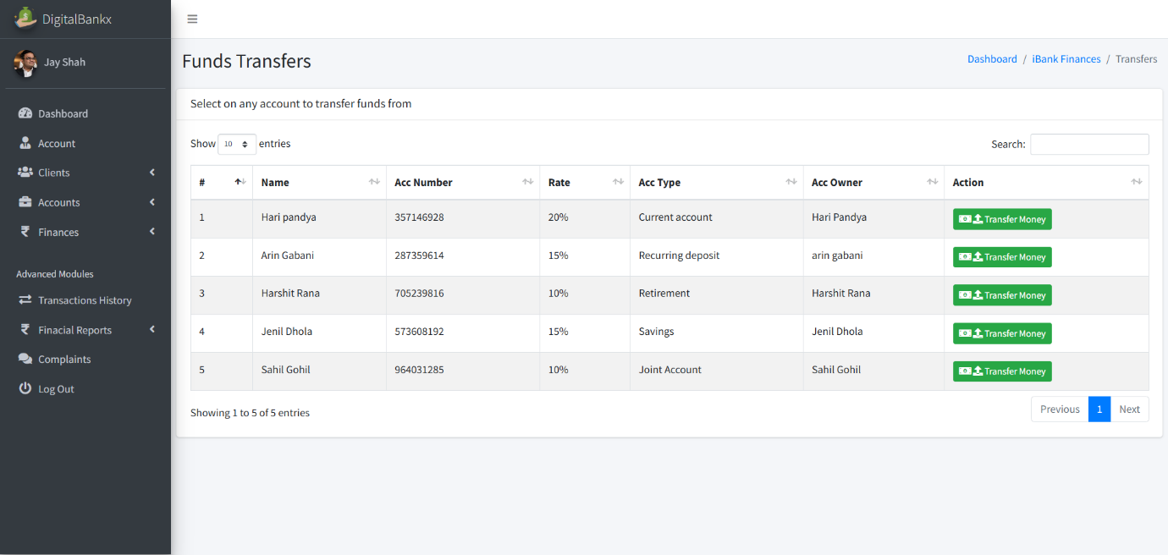

* **in this page Transfer Money section allows users to select an account, enter the recipient’s details, and send funds securely.**
* **Transferring money is used to move funds from one account to another account.**

**Transfer money :**

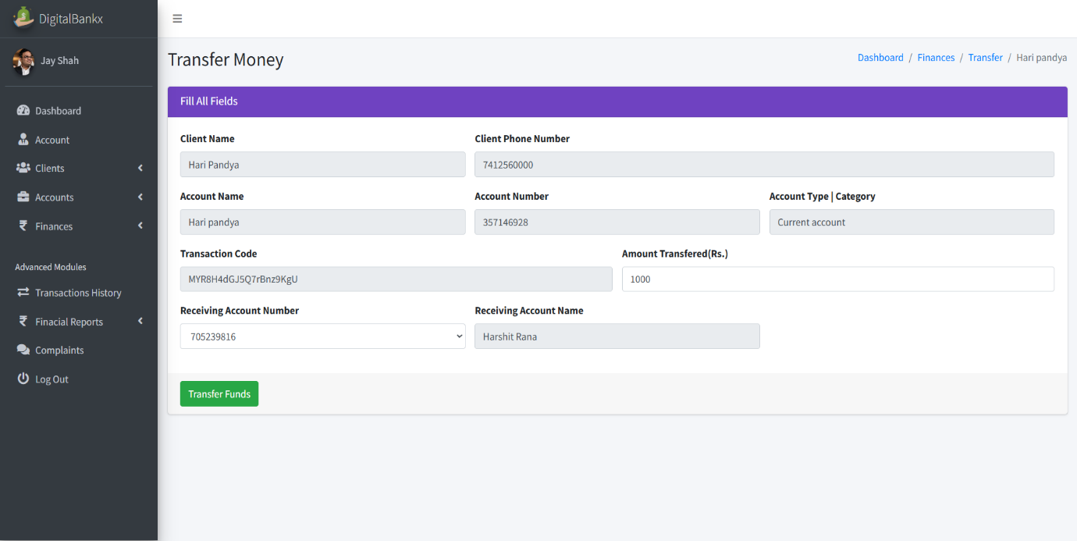

* **In this page use to section is used to move funds from one account to another.**

**Loan application:**

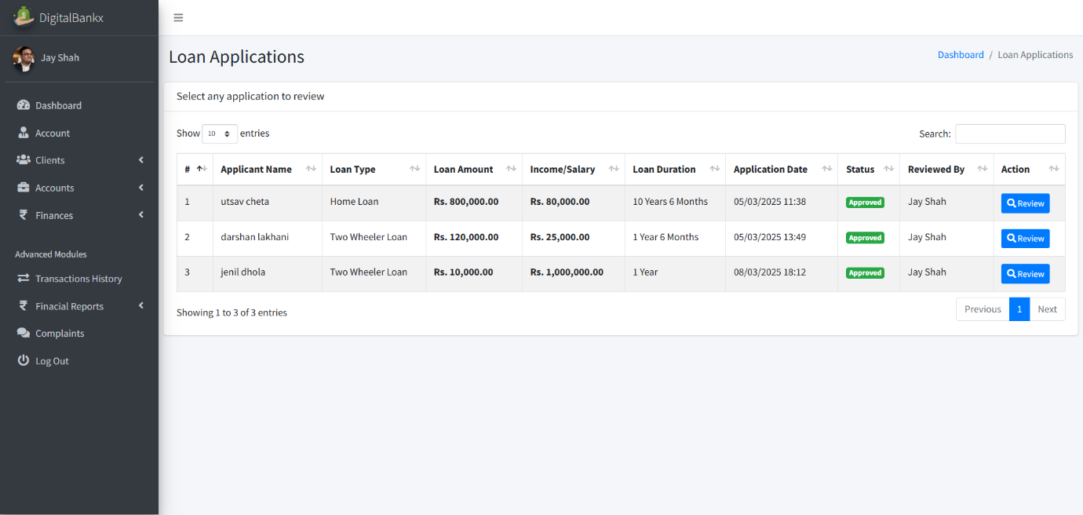

* **In this page used Loan Applications section allows users to submit and review loan requests.**
* **Customers request a loan by providing details like loan type, amount, income, and repayment duration.**

**Review loan application:**

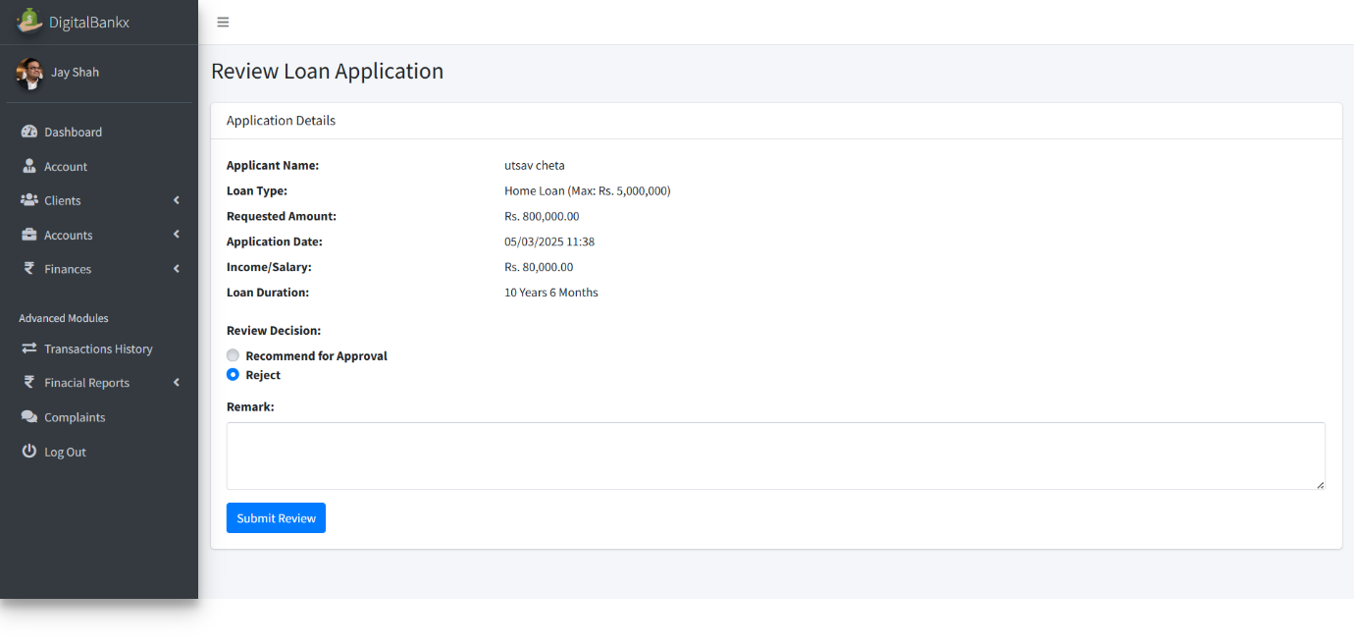

* **In this page use to evaluate and process loan requests.**
* **this feature allows financial institutions or administrators.**

**Balance Inquiries:**

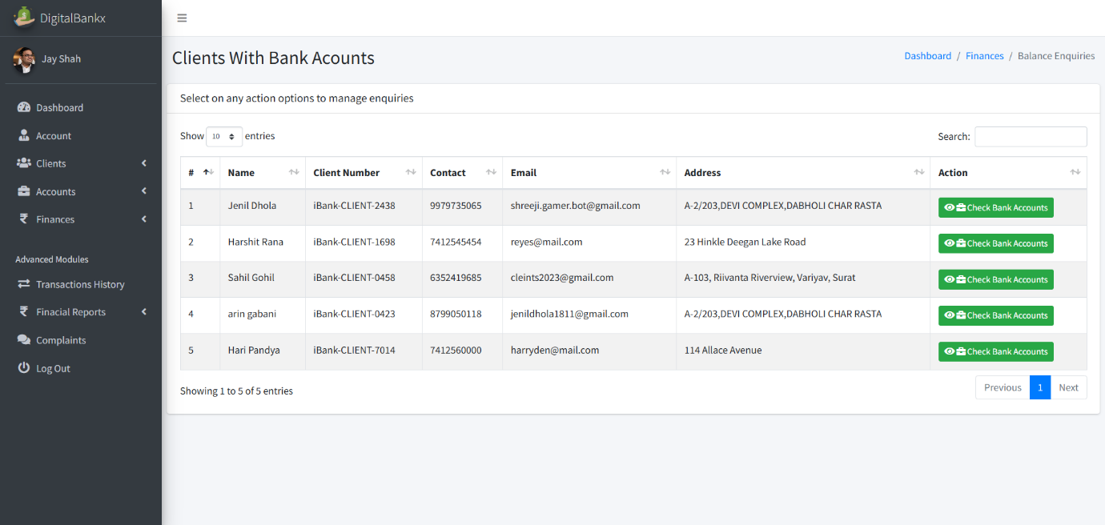

* **in this page use to check and manage the account balances of clients.**

**Check balance :**

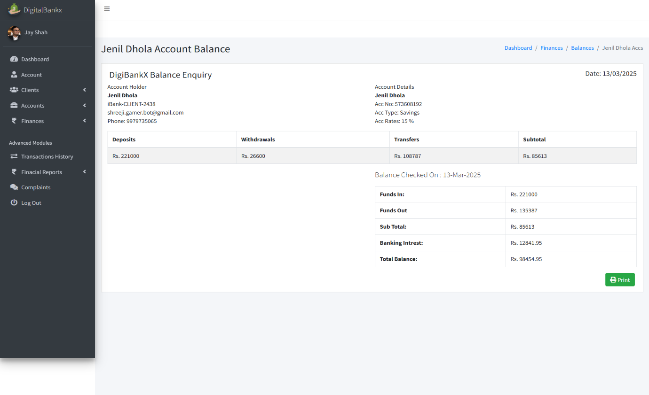

* **Check Balance section is used to view the financial status of a bank account.**
* **Displays the total funds available in the account.**

**Transaction history :**

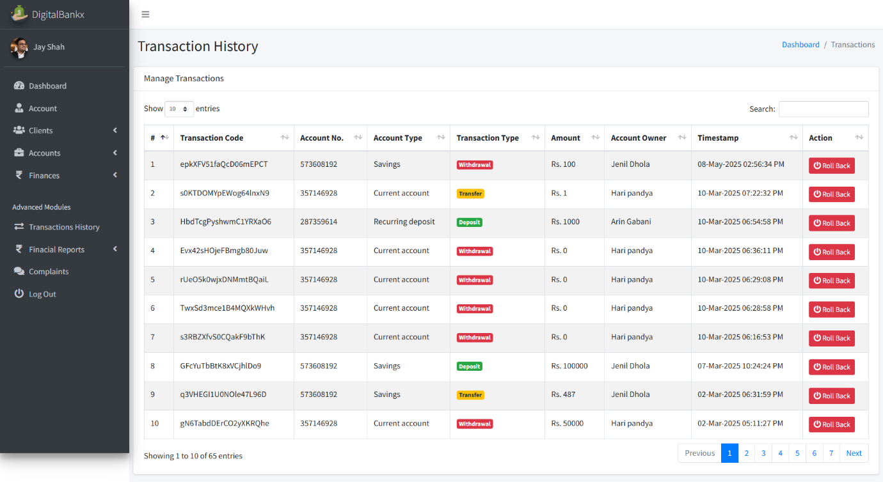

* **In this page Displays deposits, withdrawals, and transfers in one place.**
* **Includes transaction codes, account numbers, amounts, and timestamps.**

**Withdraw history :**

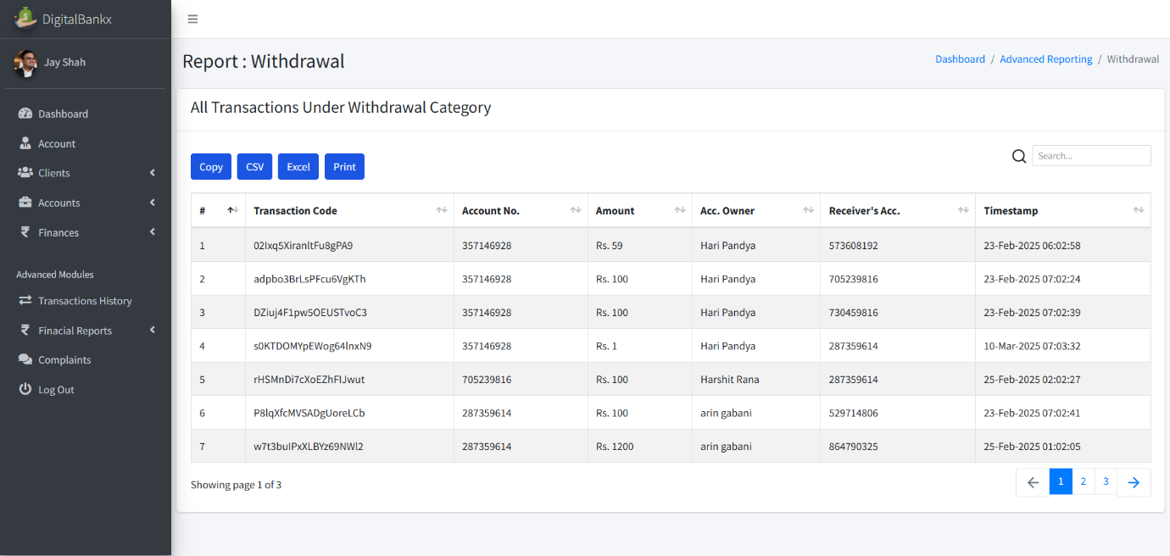

* **In this page used to track and manage all withdrawal transactions made from an account.**
* **Displays all withdrawal transactions, including the amount, account number, and account owner.**

**Deposits history :**

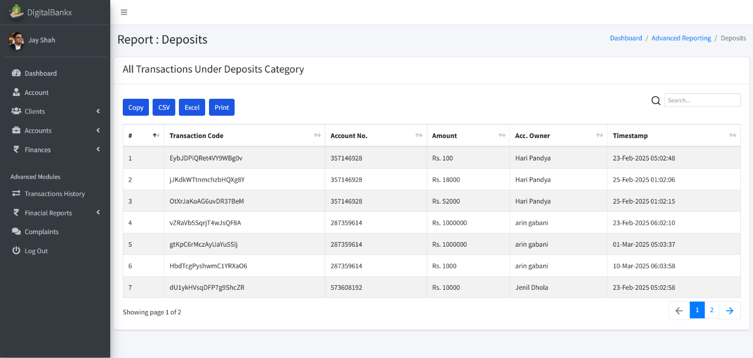

* **In this page used for tracking all deposit transactions made into a bank account.**
* **Allows users to copy, export or print reports for documentation purposes.**

**Transfer history :**



* **In this page used to track all money transfer transactions within a banking system.**
* **Displays details such as transaction codes, account numbers, transferred amounts, and timestamps.**

**Complains:**

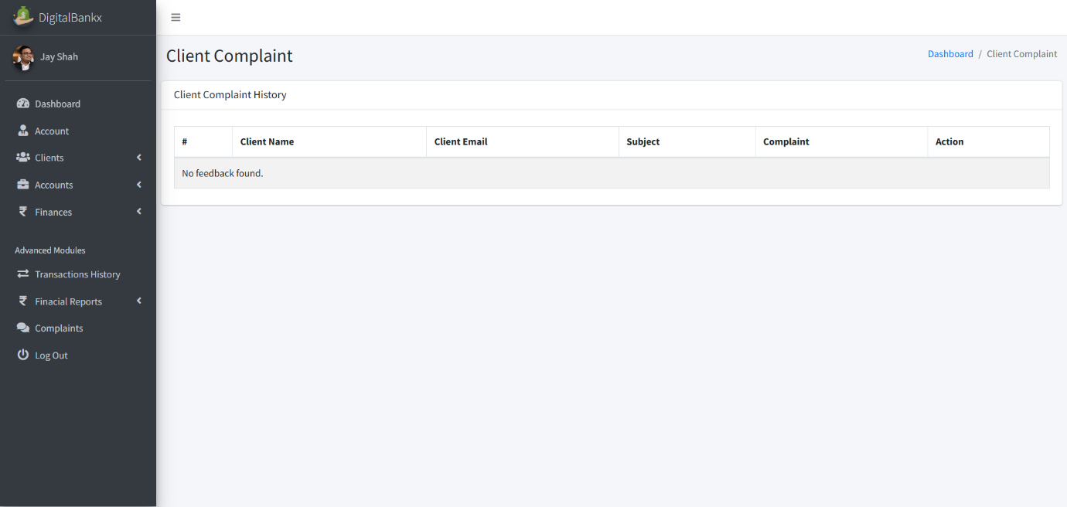

* **Displays customer complaints along with their email, subject, and details of the issue.**
* **Client Side:**

**Visitor page :**

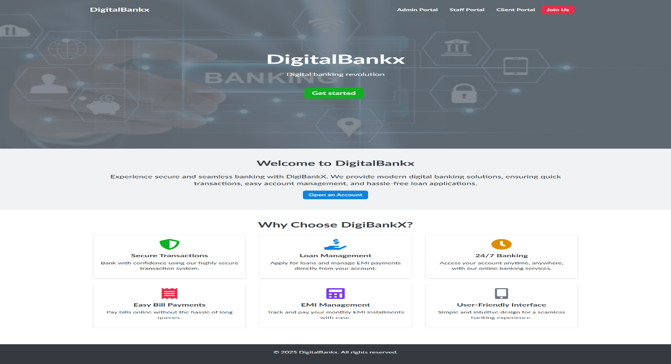

* **Visitor Page in the DigitalBankx platform serves as the landing page for new and potential users.**
* **Includes buttons for Get Started or Open an Account**

**Sign up page:**

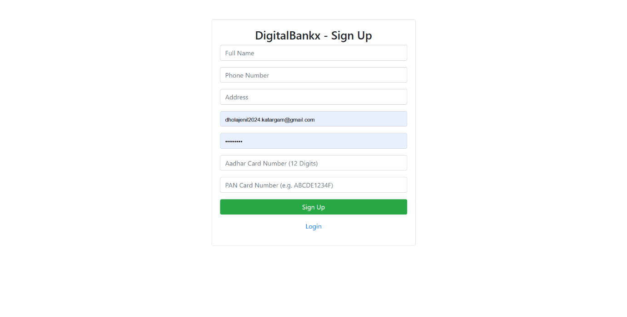

* **In this page used for new user registration, allowing customers to create an account.**
* **Requires users to enter personal details Full Name, Phone Number, Address, Email ID, Aadhar Card Number (12 Digits), PAN Card Number,**

**Password.**

**Log in page**

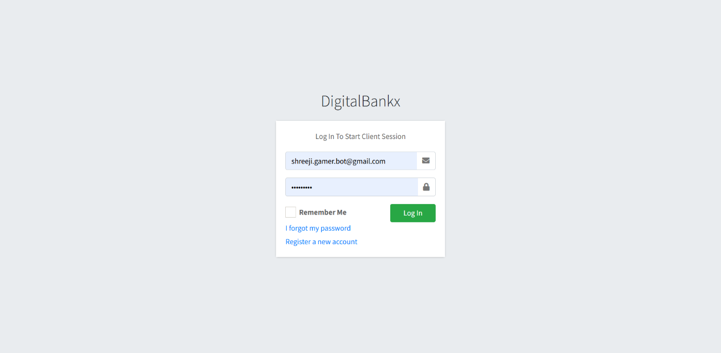

* **In this page used for user authentication, allowing existing customers to securely access their accounts.**
* **Credential Input – Users must enter: Email ID or Username ,Password**

**User dashboard**

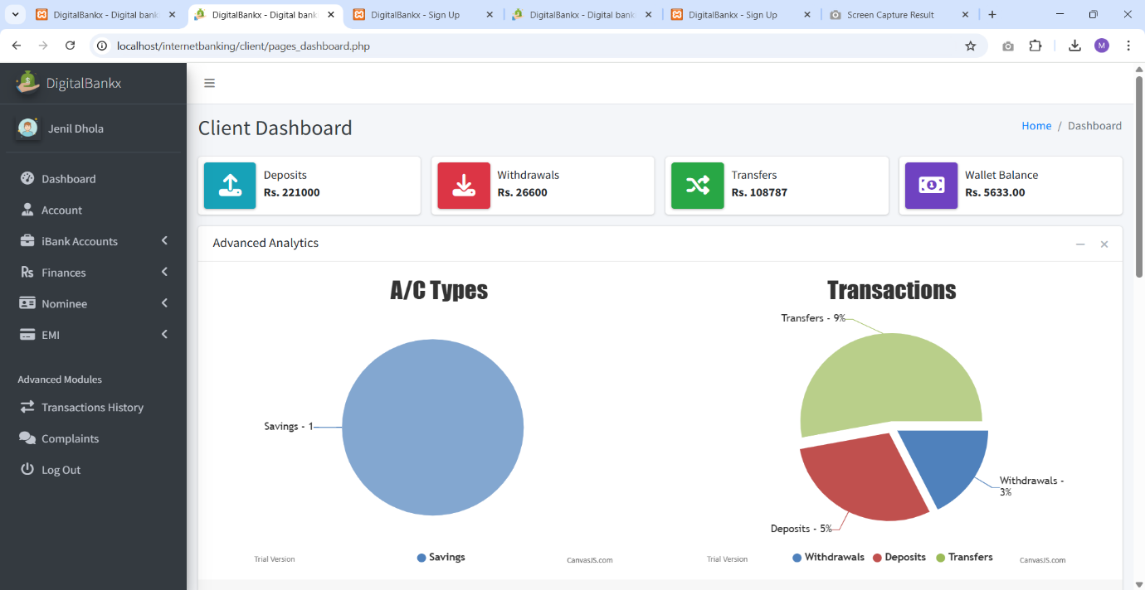

* **In this page Displays deposits, withdrawals, transfers, and wallet balance.**
* **Allows access to features like accounts, finances, transaction history, and complaints.**

**Opening account page :**

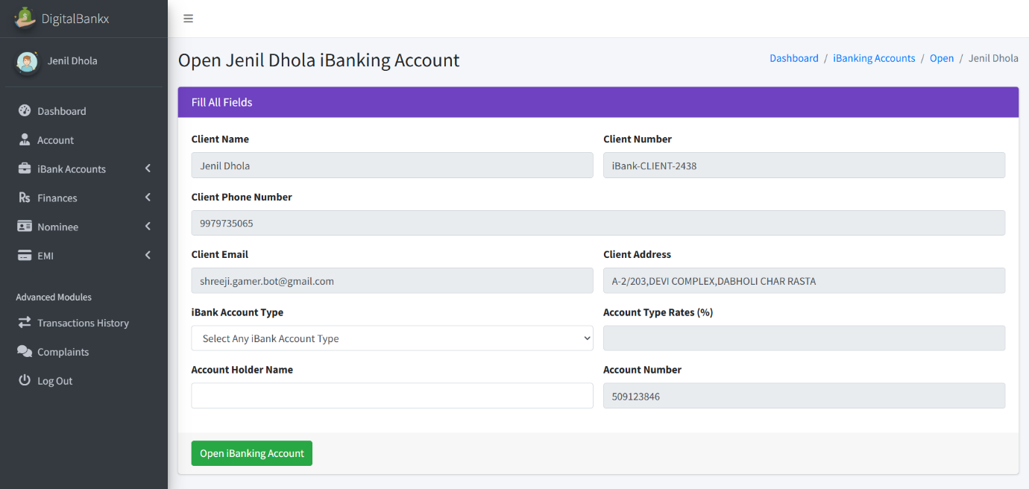

* **In this page allows users to enter their personal details and select an account type.**
* **Display client details, account details, action button.**

**My account page :**

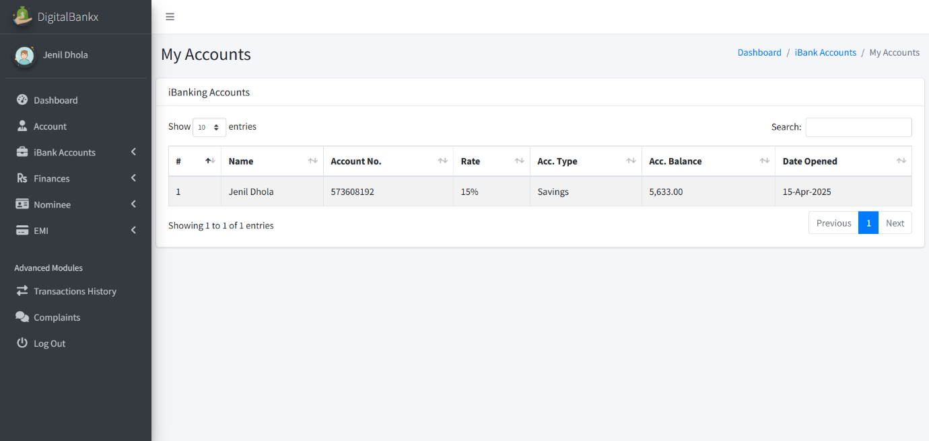

* **This page provides an overview of account-related information.**
* **Display account list table, search and pagination.**

**Deposits:**

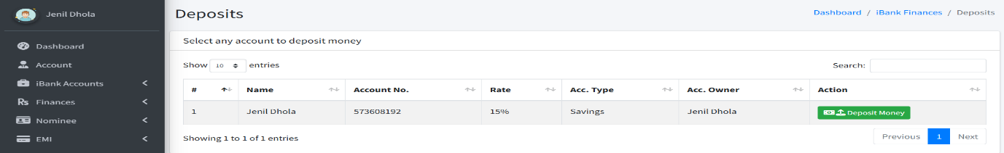

* **Display deposi**

**Transfer deposits**

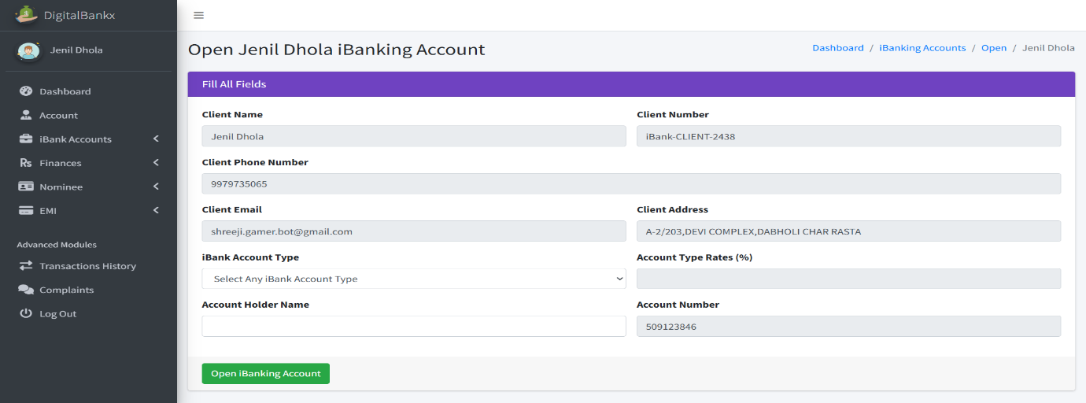

* **In this page use feature that allows users to transfer money into their bank accounts.**
* **There is a green "Open internet Banking Account" button to confirm the deposit transfer.**

**Withdrawals**

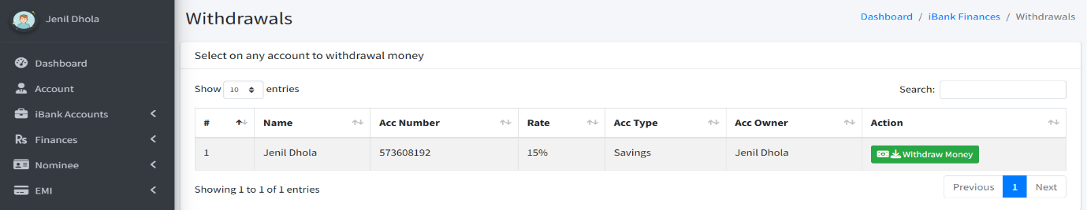

**Withdraw Money**

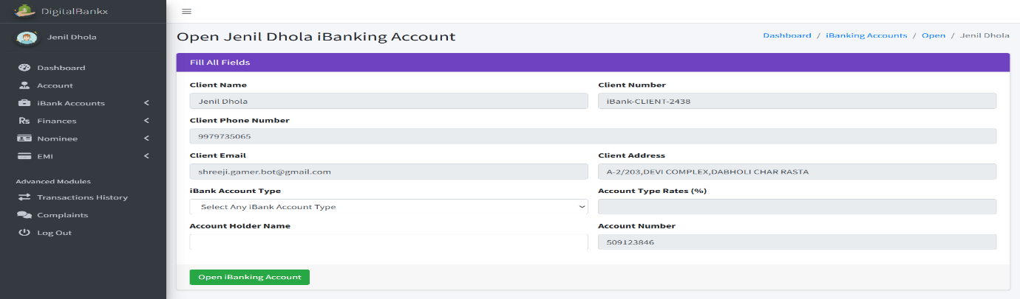

* **In this page allows users to withdraw funds from their bank accounts.**
* **A green "Open internet Banking Account" button is available to confirm the withdrawal.**

**Transfer**

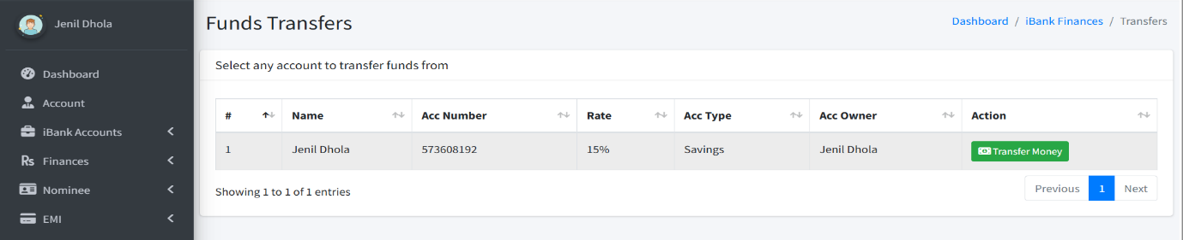

* **In this page allows users to transfer funds between accounts.**
* **A green "Transfer Funds" button is available to finalize the transfer.**

**transfer Money**

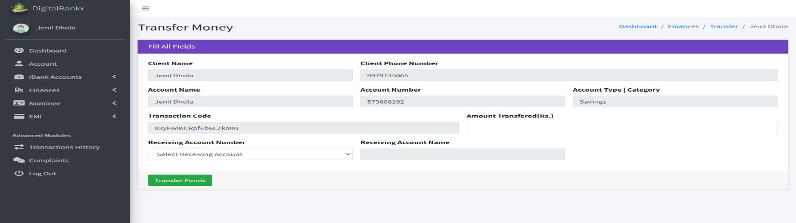

* **Click the green "Transfer Funds" button to process the transaction.**

**Apply for loan:**

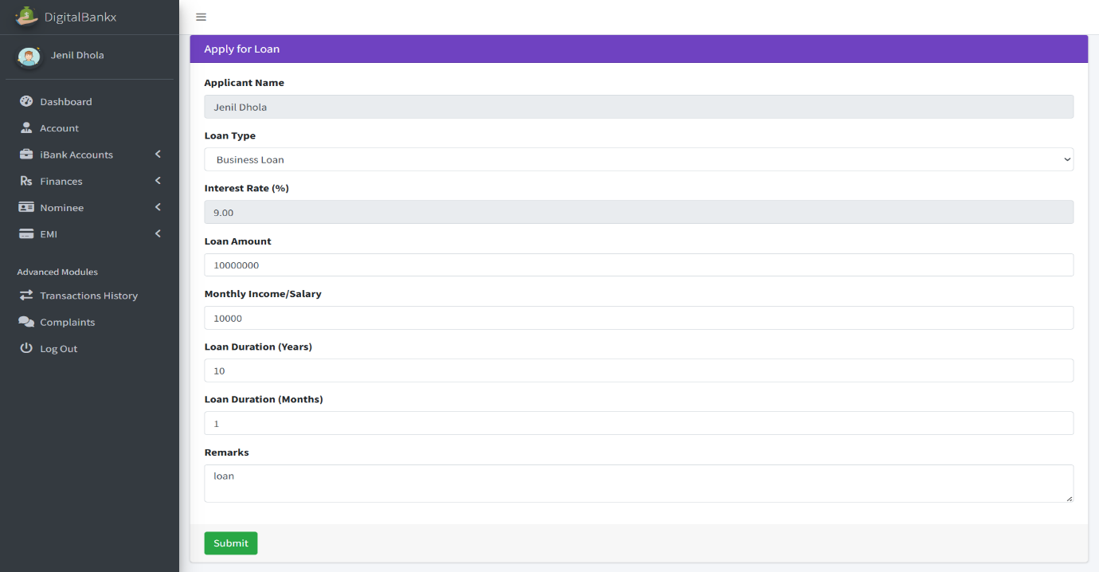

* **The user fills in the required details and submits the loan application.**
* **It enables users to apply for different types of loans: Business Loan,**

**Home Loan, Two-Wheeler Loan, Other types depending on bank options.**

**My loan application**

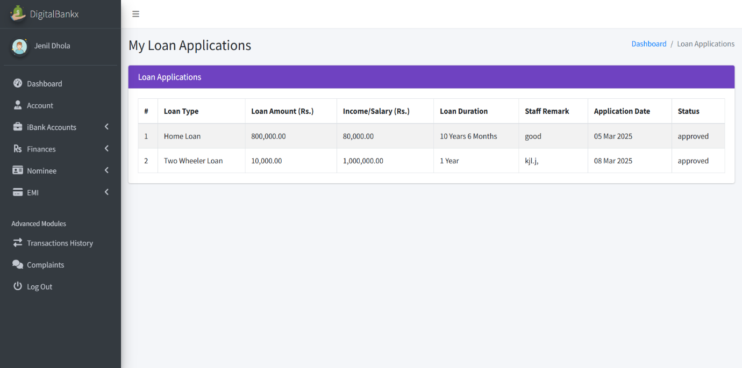

* **Display home loan and two wheeler loan.**
* **Loan application display to loan type, loan amount, income, loan duration, staff remark, application date, status.**

**Balance enquiries :**

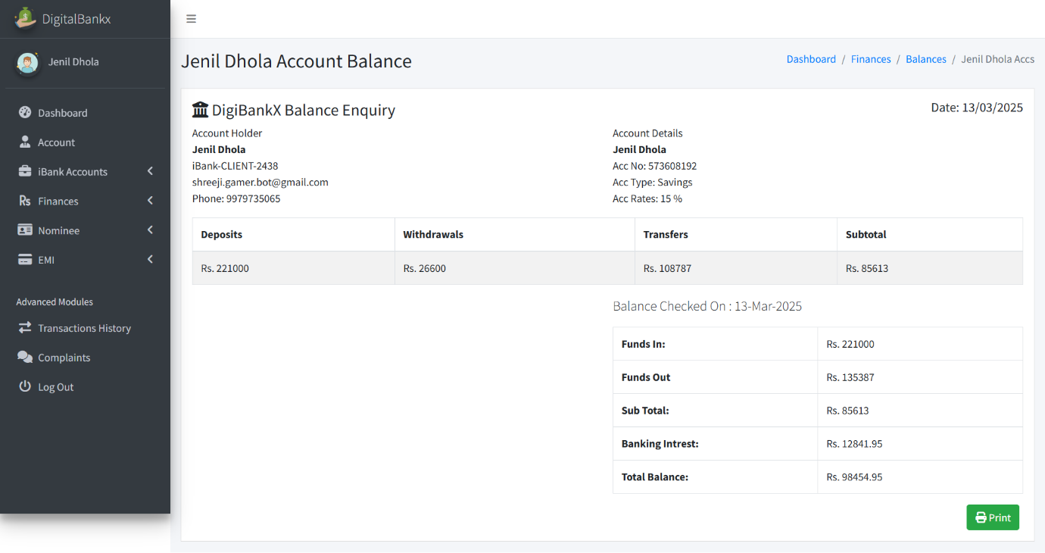

* **In this page shows the account balance details for Jenil Dhola in the DigiBankX system.**
* **It includes:**

**Deposits: ₹2,21,000**

**Withdrawals: ₹26,600**

**Transfers: ₹1,08,787**

**Subtotal: ₹86,613**

**Add nominee:**

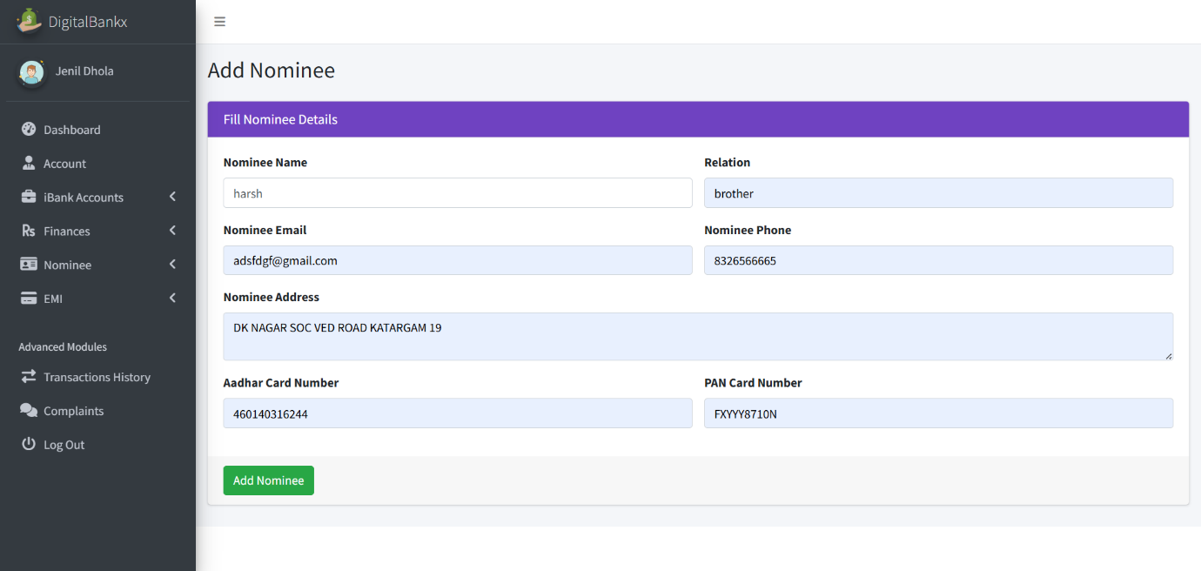

* **In this page Add Nominee" section is used for adding a nominee to a user's bank account.**
* **entering these details, the "Add Nominee" button is clicked to save the information.**

**Transaction history:**

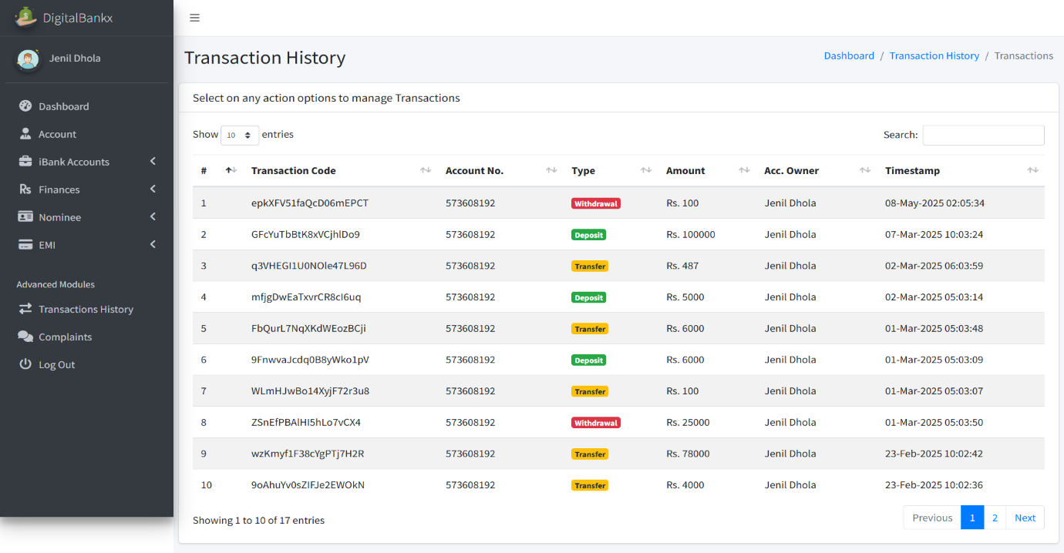

* **in this page Track Financial Activities Users can view all deposits, withdrawals, and transfers in one place.**
* **The history includes color-coded labels for transaction types: Red (Withdrawal), Yellow (Transfer) , Green (Deposit)**

**Complain :**

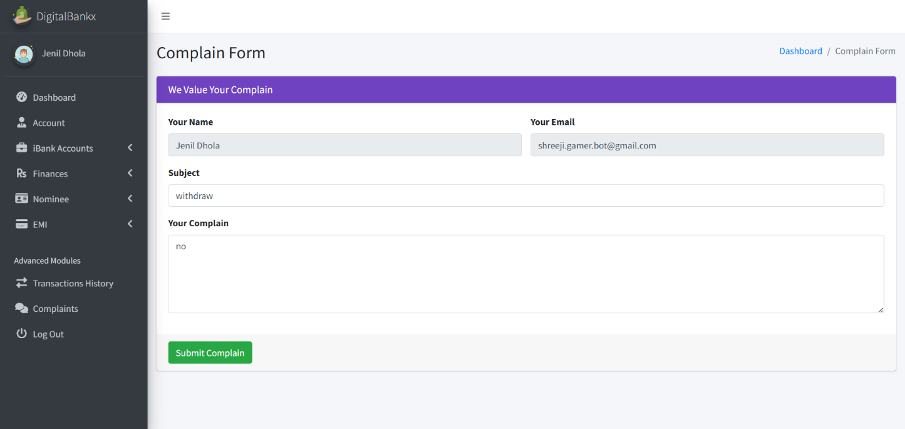

* **feature allows users to report issues related to transactions, account services, or any other banking concerns.**
* **Details in the complaint form: your name, your email, subject, your complaint, submit complaint button.**

**7**

Chapter

**System Limitation and**

**Future Enhancement**

**DigibankX** is a comprehensive **Internet Banking Management System** designed to offer secure, efficient, and user-friendly banking services. It features three key panels: **Admin**, **Staff**, and **Client**, each tailored for specific banking operations to ensure smooth financial management.

### Key Features

* **Admin Panel:** Facilitates user management, loan approvals, financial report generation, and complaint handling.
* **Staff Panel:** Manages client profiles, transaction processing, and loan applications.
* **Client Panel:** Provides account management, secure transactions, loan tracking, and complaint support.

### Limitations

* The system currently supports domestic transactions only.
* Manual intervention is required for loan approvals, potentially causing delays during peak periods.
* The complaint resolution process may experience slower response times if multiple issues arise simultaneously.

### Future Enhancements

* Implementing automated loan approvals for improved efficiency.
* Introducing biometric authentication for enhanced security.
* Adding multilingual support to cater to a broader audience.
* Developing a dedicated mobile app for improved accessibility and user convenience.
* Enhancing financial reporting with visual insights for better decision-making.

### Technologies Used

* **Front-end:** HTML, CSS, JavaScript, AJAX
* **Back-end:** PHP, MySQL
* **Libraries/Plugins:** SweetAlert, jQuery

### Conclusion

DigibankX offers a robust platform for secure and efficient online banking, combining strong data validation, AJAX-based updates, and intuitive user interfaces to improve customer experience and operational efficiency.

**8**

Chapter

|  |
| --- |
| **References** |

|  |  |
| --- | --- |
| 8.1 | Bibliography |
| 8.2 | Webography |

**8.1 Bibliography**

All the needed information related to my project “**DigiBankX as internetbanking management”** was being clumped from the following sources:

* **Books:**
* **For PHP**
* PHP Manual
* PHP 5 Fast & Easy Web Development, Julie C. Meloni, 2nd Ed, 2002.

**8.2 Webography**

* **Sites** **URL:-**
* **For PHP**
* www.php.net
* http://www.w3schools.com/php/
* **For MySQL**
* http://dev.mysql.com/doc
* **For JQuery and CSS**
* http://jquery.com/
* http://css-tricks.com/
* http://cssglobe.com/

**FOR AI**

www.chatgpt.com/